





AVYAN SONI Prof. ANURAG PUNDE (0827CS211053)

|  |  |  |
| --- | --- | --- |
| S.NO. | Experiment | Remark |
| 1. | Data Analysis Questions: I. Data Analysis Principles   1. Statistical Analytics 2. Hypothesis Testing 3. Regression 4. Correlation 5. ANOVA |  |
| 2. | Dashboard:   1. Car Collection Data Analysis 2. Order Data Analysis 3. Cookie Data Analysis 4. Loan Data Analysis 5. Shop Sales Data Analysis 6. Sales Data Sample Analysis 7. VII. Store Dataset Analysis |  |
| 3. | Reports:   1. Car Collection Data Report 2. Order Data Report 3. Cookie Data Report 4. Loan Data Report 5. Shop Sales Data Report 6. Sales Data Sample Report VII. Store Dataset Report |  |
| 4. | Analysis of Forecast Sheet in GOOGLE’s Stock prices |  |

Study on Data Analysis:

Foundational Principles, Statistical Analytics,

Hypothesis Testing, Regression Analysis,

Correlation, and Analysis of Variance

Data Analysis Principles:

The term "data analysis principles" describes the basic rules and procedures used to glean valuable insights from datasets.

1.Data quality: which places emphasis on making sure the data utilized for analysis is correct, dependable, and comprehensive. Data validation, verification, and cleansing are some of the procedures used to get rid of mistakes, inconsistencies, and missing values.

2. Data Cleaning: Cleaning up a dataset entails finding and fixing mistakes, inconsistencies, and outliers. This procedure is necessary to guarantee the correctness of the analysis results and to improve the quality of the data.

3. Exploratory Data Analysis (EDA): EDA uses statistical and visual aids to explore and summarize the primary features of the dataset. Understanding data distributions, patterns, trends, and linkages is helpful since it can direct future research and the development of hypotheses.

1. Statistical Analytics Concepts:

Statistical analytics concepts cover a variety of statistical methods and techniques used to analyze and interpret data for informed decision-making.

1.Descriptive Statistics: Descriptive statistics involve summarizing and describing the key features of a dataset, including measures of central tendency (mean, median, mode) and measures of dispersion (variance, standard deviation).

2.Inferential Statistics: Inferential statistics are used to draw conclusions or make predictions about a population based on sample data. This includes techniques like hypothesis testing, confidence intervals, and regression analysis.

3.Probability Distributions: Probability distributions describe the likelihood of different outcomes in a statistical experiment or observation. Common distributions include the normal distribution, binomial distribution, and Poisson distribution.

4.Central Limit Theorem: The Central Limit Theorem states that the sampling distribution of the sample mean tends to approach a normal distribution as the sample size increases, regardless of the population distribution's shape. This theorem is fundamental to many statistical inference techniques.

1. Hypothesis Training:

A hypothesis is a tentative statement or proposition that can be tested and evaluated through empirical observation and analysis.

1.Null Hypothesis (H0): The null hypothesis asserts that there is no significant difference or effect in the population being studied. It serves as the default assumption until evidence indicates otherwise.

2. Alternative Hypothesis (H1): The alternative hypothesis is a statement that opposes the null hypothesis, suggesting that there is a significant difference or effect in the population.

3. Hypothesis Testing: Hypothesis testing is a statistical method used to draw conclusions about population parameters based on sample data. It involves formulating a null hypothesis, selecting a significance level, collecting data, and deciding whether the evidence supports rejecting or failing to reject the null hypothesis.

1. Regression and its Types:

Regression analysis is a statistical technique used to model the relationship between a dependent variable and one or more independent variables.

1. Linear Regression: Linear regression models the relationship between the dependent variable and one or more independent variables using a linear equation. It is commonly used for predicting continuous outcomes.

Formula: 𝑦=𝛽0+𝛽1𝑥+𝜀y=β0+β1x+ε

1. Logistic Regression: Logistic regression models the probability of a binary outcome using the logistic function. It is suitable for predicting categorical outcomes with two levels.

Formula: 𝑝=11+𝑒−(𝛽0+𝛽1𝑥)p=1+e−(β0+β1x)1

1. Polynomial Regression: Polynomial regression models the relationship between the dependent variable and independent variables using a polynomial equation. It can capture non-linear relationships between variables.

|  |  |
| --- | --- |
| Formula:  xn+ε | 𝑦=𝛽0+𝛽1𝑥+𝛽2𝑥2+...+𝛽𝑛𝑥𝑛+𝜀y=β0+β1x+β2x2+...+βn |

1. Ridge and Lasso Regression: Ridge and Lasso regression are regularization techniques used to prevent overfitting in regression models by penalizing large coefficients.

1. Correlation:

Correlation measures the strength and direction of the relationship between two variables.

1. Pearson Correlation Coefficient: The Pearson correlation coefficient measures the linear relationship between two continuous variables. It ranges from -1 to 1, where -1 indicates a perfect negative correlation, 0 indicates no correlation, and 1 indicates a perfect positive correlation.

Formula: 𝑟=∑(𝑥𝑖−𝑥ˉ)(𝑦𝑖−𝑦ˉ)∑(𝑥𝑖−𝑥ˉ)2∑(𝑦𝑖−𝑦ˉ)2r=∑(xi−xˉ)2∑(yi−yˉ)2 ∑(xi−xˉ)(yi−yˉ)

1. Spearman's Rank Correlation: Spearman's rank correlation coefficient measures the strength and direction of association between two ranked variables. It is suitable for assessing monotonic relationships or correlations involving ordinal data.

6. ANOVA (Analysis of Variance):

Analysis of Variance (ANOVA) is a statistical technique used to compare means across multiple groups.

1. One-Way ANOVA: One-way ANOVA tests for differences in means across multiple groups when there is one categorical independent variable. It evaluates whether there are statistically significant differences between the group means.

2. Two-Way ANOVA: Two-way ANOVA extends one-way ANOVA by examining the effects of two categorical independent variables on a continuous dependent variable. It evaluates both the main effects of each independent variable and their interaction effects.

3. Factorial ANOVA: Factorial ANOVA analyzes the effects of multiple independent variables (factors) on a dependent variable. It is used when there are two or more categorical independent variables, allowing for the examination of both main effects and interaction effects.

# Car Collection Data Report

# 

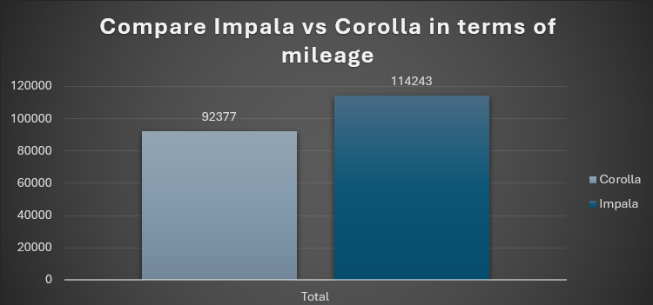

# Order Data Report

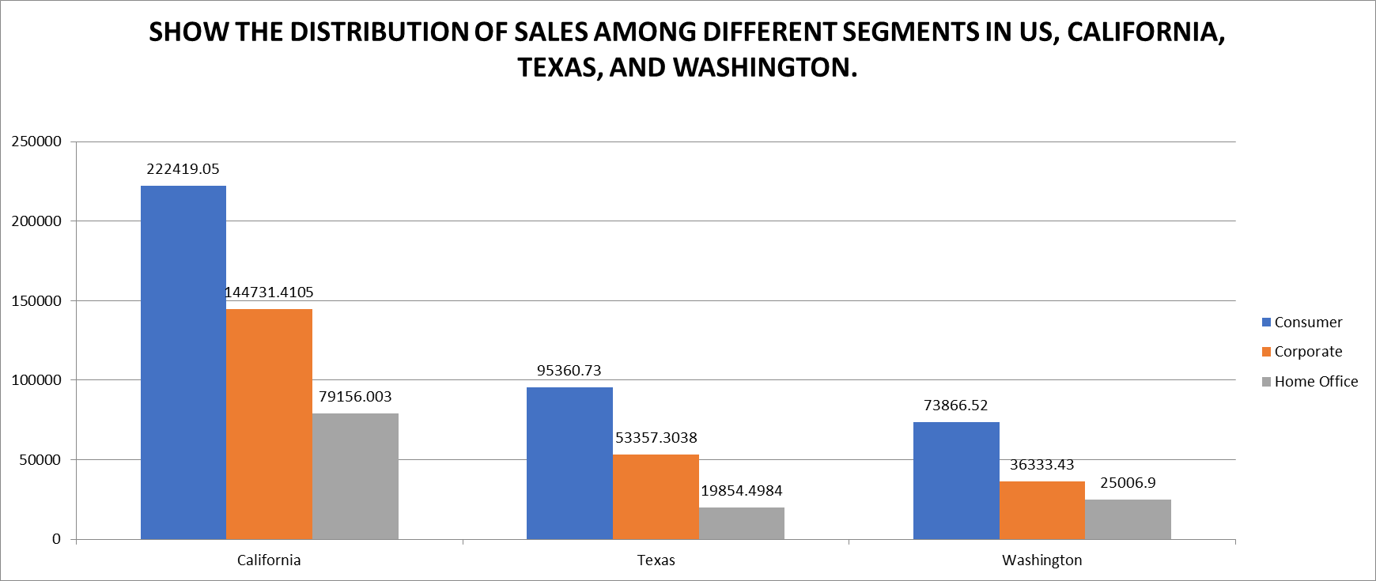

|  |
| --- |
|  |

|  |
| --- |
|  |

Cookie Data Report

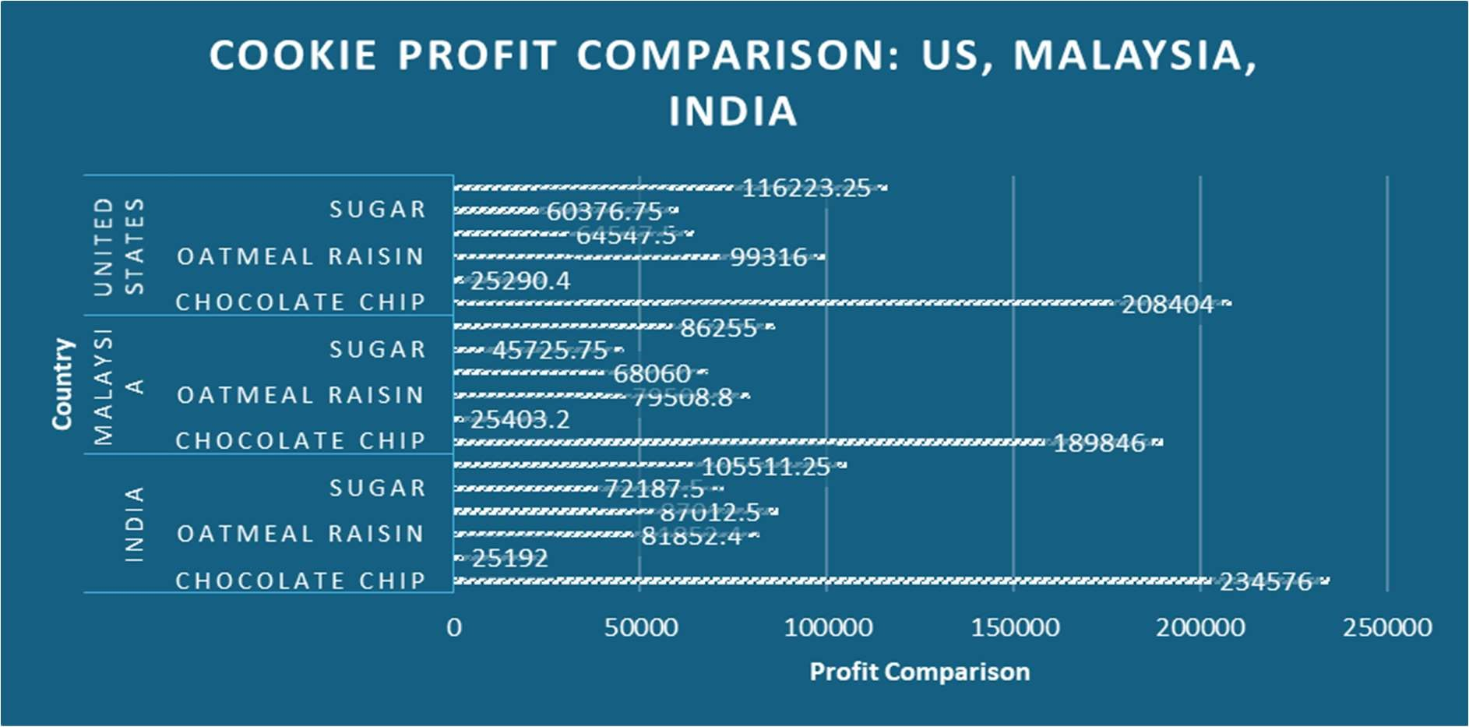

8372.351485

1658.075269

8261.595745

6316.086022

4645.513761

8940.880734

0

2000

4000

6000

8000

10000

Chocolate Chip Fortune Cookie Oatmeal Raisin Snickerdoodle Sugar White Chocolate

Macadamia Nut

Revenue

Cookie Types

Visualizing Average Cookie Revenue

Loan Data Report

|  |
| --- |
|  |

# Shop Sales Data Report

# Sales Data Sample Report

# Store Dataset Report

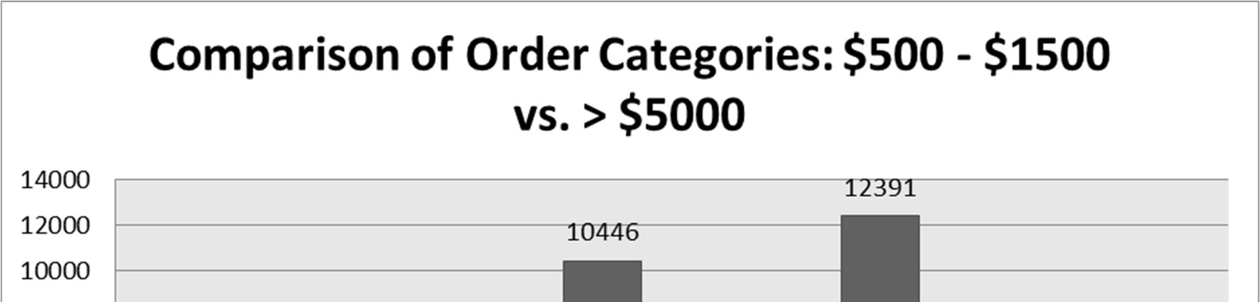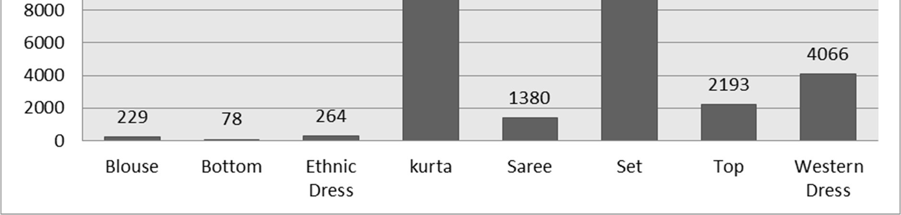

|  |  |  |
| --- | --- | --- |
|  |  |  |

## Car Collection Data Report

### Introduction

A thorough examination of the make, model, colour, mileage, price, and cost of many car models is provided by the Car Collection dataset. The purpose of this research is to analyse and extract insights from this dataset to support car-buying decision-making and help with market trends. Six distinct car models—Honda, Chevrolet, Nissan, Toyota, Dodge, and Ford—are included in the dataset.

This report's main target audience consists of auto enthusiasts, analysts, professionals in the automobile sector, and anybody curious in market trends. This report's scope includes a thorough examination of the dataset, along with statistical analysis, graphic aids, and findings interpretation.

Throughout the analysis, we have posed several key questions and performed corresponding analyses to uncover insights.

### Questionnaire

1. Compare the mileage of Chevrolet Impala to Toyota Corolla. Which of the two is giving best mileage?
2. Justify, Buying of any Ford car is better than Honda.
3. Among all the cars which car color is the most popular and is least popular?
4. Compare all the cars which are of silver color to the green color in terms of Mileage.
5. Find out all the cars, and their total cost which is more than $2000?

### Analytics

1. Compare the mileage of Chevrolet Impala to Toyota Corolla. Which of the two is giving best mileage?

In this comparison, the fuel efficiency (mileage) of two popular car models the Chevrolet Impala and the Toyota Corolla is examined. This was accomplished by filtering the dataset to eliminate information that wasn't important, and then creating a column chart. The survey found that the   Chevrolet Impala (114243) gets higher gas mileage than the Toyota Corolla (92377).

1. Justify, buying of any Ford car is better than Honda.

|  |
| --- |
|  |

This study tries to support the purchase of any Ford vehicle over a Honda by comparing their respective attributes and with a particular emphasis on price.   
The assertion was refuted by the dataset analysis, which showed that Honda cars perform better than Ford cars in terms of average price and mileage.

3.Among all the cars which car color is the most popular and is least popular?

This Based on the count of the make, this study seeks to determine which car colors are the most and least common among all the cars in the dataset.   
The data indicates that the two most popular car colors are silver and black, which make up 25% of the company's manufacturing, and blue and green cars, which make up 12% of the total.

4.Compare all the cars which are of silver color to the green color in terms of Mileage.

|  |
| --- |
|  |

The objective of this analysis is to determine which automobiles, in terms of mileage, are silver to green. The results show that there are five silver cars: the Charger, Accord, Mustang, Impala, and Corolla. Of them, the Accord has the greatest average mileage (101354). And there were two green cars: an Altima and a Silverado, with the Silverado having the greatest miles (109231).

1. Find out all the cars, and their total cost which is more than $2000?

The goal of this analysis is to determine how much the car costs over $2,000. It also displays the intended outcome by utilizing a bar graph and calculating value as the total cost. All cars over $2000 have a grand total cost of $66150.

### Conclusion and Review

Comparison: The analysis comparing the mileage of Chevrolet Impala and Toyota Corolla revealed that Chevrolet Impala provides better fuel efficiency.

Ford vs. Honda Comparison: The investigation refuted the basic assumption that Ford vehicles are more cost-effective and had higher mileage than Honda vehicles. When comparing average mileage and pricing to Ford vehicles, Honda vehicles performed better.

Proper Car Colors: Based on the data, the most common car colors are black and white, which account for 25% of all car production. Green and blue, on the other hand, were discovered to be the least common colors, making up a mere 12% of all cars produced. .

Silver vs. Green Cars Comparison: Among silver-colored cars, Accord exhibited the highest average mileage, while Silverado had the highest mileage among green-colored cars.

Automobiles Over $2000: Based on the data, the total amount spent on cars over $2000 came to $66150.

The research offered insightful information about a number of dataset components, such as mileage comparisons, the popularity of different automobile colours, and financial considerations. But there were differences between the first hypotheses and the results, especially when comparing Ford and Honda vehicles. The analysis was comprehensive and used suitable visualizations to properly display the results, like bar graphs and column charts.

All things considered, the study provides insightful information to consumers, business professionals, and scholars who wish to comprehend market developments. It's crucial to be aware of the analysis's limitations, too, including the dataset's completeness and the need for more research into other variables impacting auto purchases.

### Regression

Regression Statistics

|  |  |
| --- | --- |
| Multiple R | 0.962639 |
| R Square | 0.926673 |
| Adjusted R Square | 0.91969 |
| Standard Error | 259.2716 |
| Observations | 24 |

|  |  |  |  |  |  |  |  |  |  |
| --- | --- | --- | --- | --- | --- | --- | --- | --- | --- |
|  |  |  |  |  |  |  |  |  |  |
| ANOVA |  |  |  |  |  |  |  |  |  |
|  | df |  | SS | MS | F | Significance F |  |  |  |
| Regression |  | 2 | 17839897 | 8919948 | 132.6943 | 1.22E-12 |  |  |  |
| Residual |  | 21 | 1411657 | 67221.78 |  |  |  |  |  |
| Total |  | 23 | 19251554 |  |  |  |  |  |  |
|  |  |  |  |  |  |  |  |  |  |
|  | Coefficients | | Standard Error | t Stat | P-value | Lower 95% | Upper 95% | Lower  95.0% | Upper  95.0% |
| Intercept | 441.3528 | | 288.7848 | 1.52831 | 0.141359 | -159.208 | 1041.914 | -159.208 | 1041.914 |
| X Variable 1 | -0.00058 | | 0.001699 | -0.34395 | 0.734304 | -0.00412 | 0.002949 | -0.00412 | 0.002949 |
| X Variable 2 | 1.038413 | | 0.070492 | 14.73084 | 1.52E-12 | 0.891816 | 1.18501 | 0.891816 | 1.18501 |

This regression analysis explores the relationship between two predictors, Price and Cost, and the Total Cost of Cars using multiple linear regression. The analysis shows a moderate linear relationship, as indicated by a Multiple R value of 0.414. However, the coefficient of determination (R Square) is relatively low at 0.171, indicating that only a small portion of the variance in the Total Cost of Cars can be explained by Price and Cost. The Adjusted R Square, which accounts for the number of predictors in the model, is 0.092. The Standard Error of the estimate is 33,202.50, indicating the average deviation between observed and predicted values.

The ANOVA table evaluates the overall statistical significance of the regression model, with a p-value of 0.140, suggesting that the model may not be statistically significant at conventional levels. In the Coefficients table, the intercept is estimated at 133,934.06, representing the Total Cost when both predictors are zero. The coefficients for Price and Cost are -9.58 and -6.87, respectively, indicating a minimal change in Total Cost for a one-unit increase in each predictor.

### Anova: one factor

|  |  |  |  |  |  |  |  |
| --- | --- | --- | --- | --- | --- | --- | --- |
| Anova: Single Factor | |  |  |  |  |  |  |
|  |  |  |  |  |  |  |  |
| SUMMARY |  |  |  |  |  |  |  |
| Groups | Count |  | Sum | Average | Variance |  |  |
| Price | 24 |  | 78108 | 3254.5 | 837024.087 |  |  |
| Cost | 24 |  | 66150 | 2756.25 | 705502.717 |  |  |
|  |  |  |  |  |  |  |  |
| ANOVA |  |  |  |  |  |  |  |
| Source of Variation | SS |  | df | MS | F | P-value | F crit |
| Between Groups | 2979036.8 |  | 1 | 2979036.8 | 3.86254131 | 0.055430249 | 4.051748692 |
| Within Groups | 35478117 |  | 46 | 771263.4 |  |  |  |
|  |  |  |  |  |  |  |  |
| Total | 38457153 |  | 47 |  |  |  |  |

### This ANOVA compares the means of two groups, Price and Cost, in relation to their influence on the Total Cost of Cars. The Price group has an average of $3,254.50 and a total sum of $78,108, while the Cost group has an average of $2,756.25 and a total sum of $66,150. The analysis reveals a slight difference in means between the groups, but it is not statistically significant at the conventional significance level (p = 0.0554). Further investigation with a larger sample size may be necessary for more conclusive results.

### The p-value suggests a slight tendency toward a difference in means between the two groups, but it is not significant at the conventional α = 0.05 level. The "Within Groups" sum of squares (SS) is 35,478,117 with 46 degrees of freedom (df), resulting in a mean square (MS) of 771,263.4. The total sum of squares (SS) is 38,457,153 with 47 degrees of freedom (df).

### Anova Two Factor

|  |  |  |  |  |
| --- | --- | --- | --- | --- |
| SUMMARY | Count | Sum | Average | Variance |
| Row 1 | 3 | 70512 | 23504 | 1.2E+09 |
| Row 2 | 3 | 99635 | 33211.67 | 2.88E+09 |
| Row 3 | 3 | 104854 | 34951.33 | 3.31E+09 |
| Row 4 | 3 | 79104 | 26368 | 1.77E+09 |
| Row 5 | 3 | 76673 | 25557.67 | 1.47E+09 |
| Row 6 | 3 | 60703 | 20234.33 | 9.19E+08 |
| Row 7 | 3 | 91602 | 30534 | 2.41E+09 |
| Row 8 | 3 | 135682 | 45227.33 | 5.48E+09 |
| Row 9 | 3 | 63329 | 21109.67 | 1.09E+09 |
| Row 10 | 3 | 143412 | 47804 | 6.21E+09 |
| Row 11 | 3 | 96023 | 32007.67 | 2.44E+09 |
| Row 12 | 3 | 118690 | 39563.33 | 3.64E+09 |
| Row 13 | 3 | 94966 | 31655.33 | 2.35E+09 |
| Row 14 | 3 | 145151 | 48383.67 | 6.41E+09 |
| Row 15 | 3 | 145661 | 48553.67 | 6.18E+09 |
| Row 16 | 3 | 69505 | 23168.33 | 1.21E+09 |
| Row 17 | 3 | 49123 | 16374.33 | 4.48E+08 |
| Row 18 | 3 | 48366 | 16122 | 4.85E+08 |
| Row 19 | 3 | 58171 | 19390.33 | 6.72E+08 |
| Row 20 | 3 | 107270 | 35756.67 | 3.28E+09 |
| Row 21 | 3 | 47301 | 15767 | 5.38E+08 |
| Row 22 | 3 | 42702 | 14234 | 3.19E+08 |
| Row 23 | 3 | 66425 | 22141.67 | 9.74E+08 |
| Row 24 | 3 | 140665 | 46888.33 | 6.06E+09 |
|  |  |  |  |  |
| Column 1 | 24 | 2011267 | 83802.79 | 1.21E+09 |
| Column 2 | 24 | 66150 | 2756.25 | 705502.7 |
| Column 3 | 24 | 78108 | 3254.5 | 837024.1 |
|  |  |  |  |  |

|  |  |  |  |  |  |  |
| --- | --- | --- | --- | --- | --- | --- |
|  |  |  |  |  |  |  |
| ANOVA |  |  |  |  |  |  |
| Source of  Variation | SS | df | MS | F | P-value | F crit |
| Rows | 8.95E+09 | 23 | 3.89E+08 | 0.941208 | 0.549982 | 1.766805 |
| Columns | 1.04E+11 | 2 | 5.22E+10 | 126.3564 | 2.05E-19 | 3.199582 |

|  |  |  |  |  |  |  |
| --- | --- | --- | --- | --- | --- | --- |
| Error | 1.9E+10 | 46 | 4.13E+08 |  |  |  |
|  |  |  |  |  |  |  |
| Total | 1.32E+11 | 71 |  |  |  |  |

### This dataset summarizes data across 24 rows and 3 columns, detailing counts, sums, averages, and variances. Each row represents a distinct category, while the columns denote different attributes. For example, the first column includes 24 observations with a total sum of $2,011,267, an average of $83,802.79, and a variance of $1.21 billion.

### The ANOVA table identifies the sources of variation: rows, columns, and error. Specifically, the rows' sum of squares (SS) is $8.95 billion with 23 degrees of freedom (df), and a mean square (MS) of $389 million, resulting in an F-value of 0.941 and a non-significant p-value of 0.55. In contrast, the columns' SS is $104 billion with 2 df, yielding an F-value of 126.36 and a very low p-value of 2.05E-19, indicating significant differences between columns. The error SS is $19 billion with 46 df, and the total SS is $132 billion.

### Descriptive Statistics

|  |  |  |  |  |  |
| --- | --- | --- | --- | --- | --- |
| Column1 |  | Column2 |  | Column3 |  |
|  |  |  |  |  |  |
| Mean | 83802.79 | Mean | 2756.25 | Mean | 3254.5 |
| Standard Error | 7112.652 | Standard Error | 171.4525 | Standard Error | 186.7512 |
| Median | 81142 | Median | 2750 | Median | 3083 |
| Mode | #N/A | Mode | 3000 | Mode | #N/A |
| Standard Deviation | 34844.74 | Standard Deviation | 839.9421 | Standard Deviation | 914.8902 |
| Sample Variance | 1.21E+09 | Sample Variance | 705502.7 | Sample Variance | 837024.1 |
| Kurtosis | -1.09718 | Kurtosis | -0.81266 | Kurtosis | -1.20291 |
| Skewness | 0.386522 | Skewness | 0.473392 | Skewness | 0.272019 |
| Range | 105958 | Range | 3000 | Range | 2959 |
| Minimum | 34853 | Minimum | 1500 | Minimum | 2000 |
| Maximum | 140811 | Maximum | 4500 | Maximum | 4959 |
| Sum | 2011267 | Sum | 66150 | Sum | 78108 |
| Count | 24 | Count | 24 | Count | 24 |

### This dataset provides summaries for three columns: Column1, Column2, and Column3, each representing distinct attributes. Column1 features larger monetary values with a mean of $83,802.79 and significant variability, indicated by a standard deviation of $34,844.74 and a wide range from $34,853 to $140,811. Column2 shows smaller values, with a mean of $2,756.25, and less variability compared to Column1, as reflected by a standard deviation of $839.94 and a narrower range from $1,500 to $4,500. Column3 contains values similar in magnitude to Column2 but with slightly higher variability, illustrated by a mean of $3,254.5, a standard deviation of $914.89, and a range from $2,000 to $4,959. Each column's statistics, including mean, median, mode, standard deviation, skewness, kurtosis, and range, provide insights into the distribution and characteristics of the respective attributes across 24 observations.

### Correlation

|  |  |  |  |
| --- | --- | --- | --- |
|  | Column |  | Column |
|  | 1 |  | 2 |
| Column  1 | 1 |  |  |
| Column  2 | -  0.41106 |  | 1 |

The correlation data provided indicates a relationship between Column 1 and Column 2. A correlation coefficient of 1 for Column 1 with itself indicates a perfect positive correlation, as expected when a variable is correlated with itself. However, the correlation coefficient of -0.41106 between Column 1 and Column 2 suggests a moderate negative correlation. This negative correlation suggests that as values in Column 1 increase, values in Column 2 tend to decrease, and vice versa. While the correlation is not very strong, it still suggests a discernible pattern in the relationship between the two variables. This understanding can be valuable for grasping how changes in one variable may affect the other, potentially guiding decision-making or further analysis depending on the data's context.

## Order Data Report

### Introduction

This report explores a vast dataset that records sales transactions in the automotive sector. It includes a variety of variables, including Order ID, Order Date, Ship Date, Customer Information, Product Details, and Sales Figures. Finding practical insights to guide decisionmaking and promote corporate expansion in the automobile industry is the main goal of this investigation. This analysis looks at sales data from several US states, sectors, categories, and subcategories in order to pinpoint important trends, high-performing segments, and possible growth prospects. The insights obtained from this study will be extremely beneficial to stakeholders in the automobile sector, such as executives, marketers, and sales managers, who are looking to maximize income, improve customer happiness, and optimize sales methods.

### Questionnaire

1. Compare all the US states in terms of Segment and Sales. Which Segment performed well in all the states?
2. Find out top performing category in all the states?
3. Which segment has the most sales in the US, California, Texas, and Washington?
4. Compare total and average sales for all different segments?
5. Compare the average sales of different categories and subcategory of all the states.

### Analytics

1.Compare all the US states in terms of Segment and Sales. Which Segment performed well in all the states?

222419.05

32675.948

44252.611

36576.371

174100.923

42628.544

66818.653

95360.73

73866.52

"Segment Performance by Sales Across US States"

California

Florida

Illinois

Michigan

New York

Ohio

Pennsylvania

Texas

Washington

California (222419.05) was found to have the most sales when all the states were compared in terms of sector and sales. The consumer category (1148060.531) showed good performance across all states.

1. Find out top performing category in all the states?

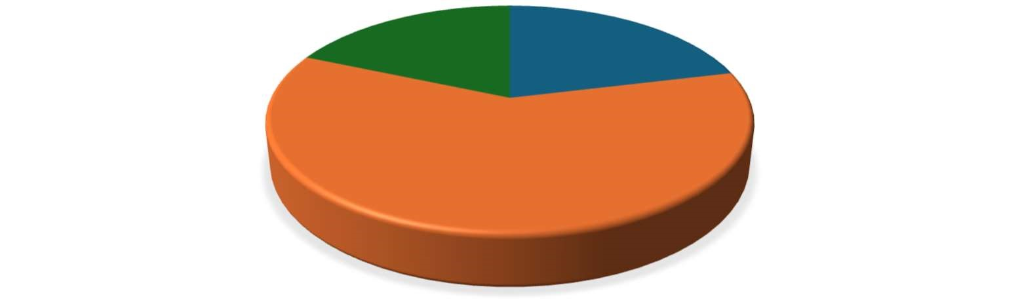

Furniture, 2078,

21

%

Office Supplies,

5909

, 60%

Technology, 1813,

19

%

TOP-PERFORMING CATEGORY IN ALL THE STATES

Office supplies lead as the highest-performing category across all states with a total sales count of 5909, followed by technology at 1813 and furniture at 2078.

1. Which segment has most sales in US, California, Texas, and Washington?

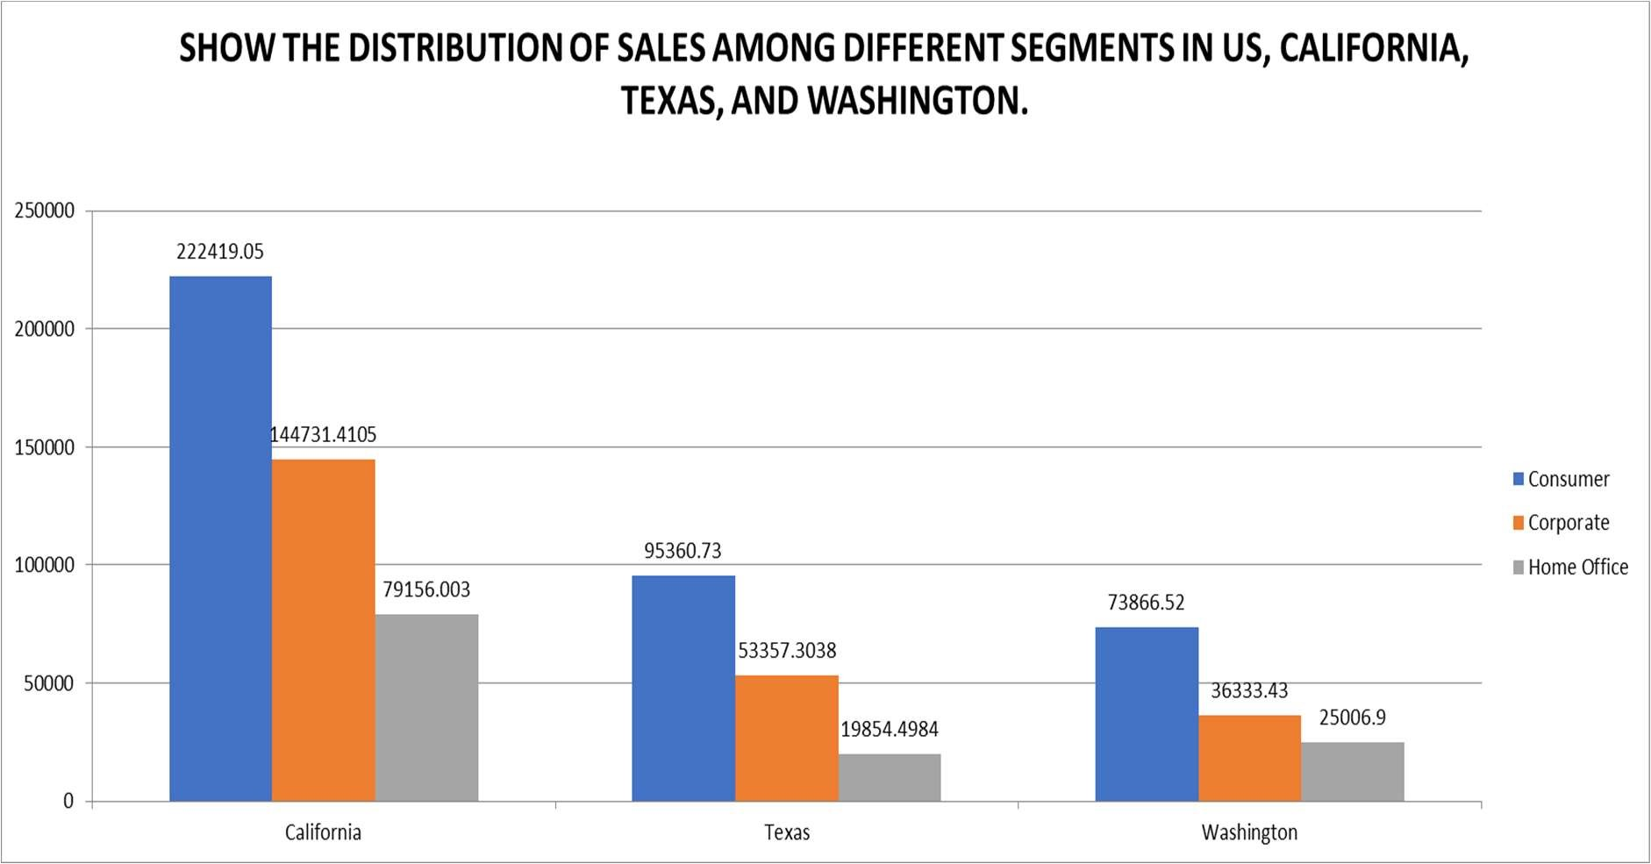

Using a bar chart to display the proportion of distribution and filtering the states for the overall sales count. The US, California, Texas, and Washington have the highest sales in the consumer category.

1. Compare total and average sales for all different segments?

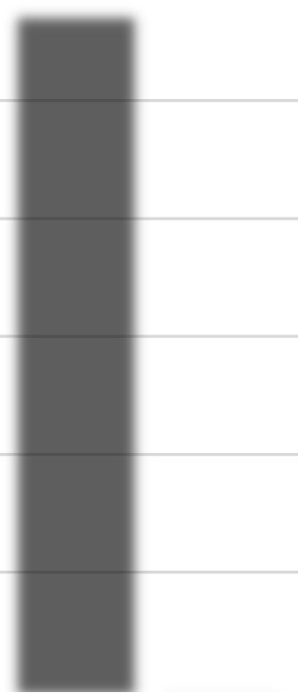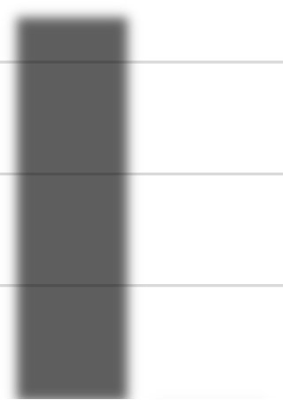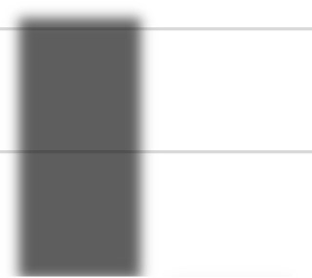

1148060.531

688494.0748

424982.1769

225.0657775

233.1507195

243.4033086

0

200000

400000

600000

800000

1000000

1200000

1400000

Consumer

Corporate

Home Office

SALES

SEGMENTS

Total vs. Average Sales per Segment



Sum of Sales



Average of Sales

It is clearly visible that the consumer segment has higher average sales with 1148060.531 and home office segment has total sales of 243.40.

1. Compare average sales of different categories and subcategory of all the states.

|  |  |  |  |  |  |  |  |  |  |  |  |  |  |  |  |  |  |  |  |  |  |  |  |  |  |  |  |  |  |  |  |  |  |  |  |  |  |  |  |  |  |  |  |  |  |  |  |  |  |  |  |  |  |  |  |  |  |
| --- | --- | --- | --- | --- | --- | --- | --- | --- | --- | --- | --- | --- | --- | --- | --- | --- | --- | --- | --- | --- | --- | --- | --- | --- | --- | --- | --- | --- | --- | --- | --- | --- | --- | --- | --- | --- | --- | --- | --- | --- | --- | --- | --- | --- | --- | --- | --- | --- | --- | --- | --- | --- | --- | --- | --- | --- | --- |
| |  |  |  |  |  |  |  |  |  |  |  |  |  |  |  |  |  |  |  | | --- | --- | --- | --- | --- | --- | --- | --- | --- | --- | --- | --- | --- | --- | --- | --- | --- | --- | --- | | 503.5982243 | 531.8331647 | 95.82386466 | 645.8937197 | 227.9268039 | 34.01963057 | 134.0675503 | 65.03244355 | 14.02785047 | 34.58746779 | 57.4202571 | 263.6338846 | 252.2842826 | 217.1781746 |  |  |  |  | 374.1808767 | | BOOKCASES  CHAIRS  FURNISHINGS | | | TABLES | APPLIANCES | ART  BINDERS  ENVELOPES  FASTENERS  LABELS  PAPER | | | | | | STORAGE | SUPPLIES | ACCESSORIES  COPIERS  MACHINES  PHONES | | | | | | | FU RNI TU RE | | |  |  | OFF ICE S UPPLIE S | | | | | |  |  | TE CHNOLOGY | | | | | |   AVERAGE SALES BY CATEGORY AND SUBCATEGORY.  2215.880212  1645.553313  SALES  CATEGORY |

The analysis shows the average sales for the 3 categories having multiple subcategories, the categories are Furniture, Office Supplies, Technology.

### Conclusion and Review

The examination of sales statistics in the automobile sector yields numerous significant conclusions. When it comes to sales volume, California is the best-performing state, and the consumer category does well in every state. According to consumer preferences, Office Supplies is the category that performs the best, followed by Furniture and Technology. Sales in the US are regularly led by the consumer market, especially in California, Texas, and Washington.

The data also shows that the Consumer sector's average sales are greater than those of the Home Office category. All things considered, these insights offer insightful advice that can be used to enhance client interaction, optimize sales tactics, and propel corporate success in the automobile sector.

### Regression

|  |  |
| --- | --- |
| SUMMARY OUTPUT | |
|  |  |
| Regression Statistics |  |
| Multiple R | 0.000434 |
| R Square | 1.88E-07 |
| Adjusted R Square | -0.0001 |
| Standard Error | 625.334 |
| Observations | 9789 |

|  |  |  |  |  |  |  |  |  |
| --- | --- | --- | --- | --- | --- | --- | --- | --- |
| ANOVA |  |  |  |  |  |  |  |  |
|  | df | SS | MS | F | Significance F |
| Regression | 1 | 721.1637 | 721.1637 | 0.001844 | 0.965747 |
| Residual | 9787 | 3.83E+09 | 391042.6 |  |  |
| Total | 9788 | 3.83E+09 |  |  |  |
|  |  |  |  |  |  |
|  | Coefficients | Standard Error | t Stat | P-value | Lower 95% | Upper 95% | Lower  95.0% | Upper  95.0% |
| Intercept | 230.5863 | 12.63999 | 18.24261 | 3.83E-73 | 205.8093 | 255.3633 | 205.8093 | 255.3633 |
| X Variable 1 | -9.6E-05 | 0.002235 | -0.04294 | 0.965747 | -0.00448 | 0.004286 | -0.00448 | 0.004286 |

### The regression output reveals an exceedingly weak and statistically insignificant relationship between the independent variable (X Variable 1) and the dependent variable. The Multiple R value of 0.000434 suggests an almost negligible correlation, while the R Square value of approximately 0.000000188 indicates that virtually none of the variation in the dependent variable is explained by the independent variable. Additionally, the Adjusted R Square, slightly negative (-0.0001), emphasizes the poor explanatory power of the model. Both the F-statistic (0.001844) and the Significance F value (0.965747) further underscore that the regression model does not fit the data well and is not statistically significant.

### Descriptive Statistics

|  |  |
| --- | --- |
| Column1 | |
|  |  |
| Mean | 230.1162 |
| Standard Error | 6.320053 |
| Median | 54.384 |
| Mode | 12.96 |
| Standard Deviation | 625.3021 |
| Sample Variance | 391002.7 |
| Kurtosis | 307.3056 |
| Skewness | 13.05363 |
| Range | 22638.04 |
| Minimum | 0.444 |
| Maximum | 22638.48 |
| Sum | 2252607 |
| Count | 9789 |
|  |  |

The statistical summary for Column1 offers a comprehensive overview of the distribution and characteristics of the data. The mean value of 230.1162 represents the dataset's average, while the standard error of 6.320053 indicates a moderate level of precision around the mean estimate. The median, at 54.384, underscores the data's central tendency, and the mode of 12.96 signifies the most frequently occurring value.

With a standard deviation of 625.3021 and a sample variance of 391002.7, the dataset demonstrates significant variability. High kurtosis (307.3056) and skewness (13.05363) values indicate a heavily tailed and highly right-skewed data distribution, respectively. The data range is substantial, extending from a minimum value of 0.444 to a maximum of 22638.48, encompassing a total range of 22638.04.

The sum of all values amounts to 2,252,607, and the total number of observations is 9789, reflecting a large dataset. This statistical summary suggests that although the average value is relatively low, the presence of extreme outliers and the asymmetrical distribution of the data should be noted.

## Cookie Data Report

### Introduction

Six distinct varieties of cookies are included in our cookie data set: chocolate chip, fortune cookie, sugar, oatmeal raisin, Snicker doodle, and white chocolate macadamia nut. We possess an abundance of information on these cookies, including the quantity sold, the expenses incurred, the income (revenue), and the earnings. Not only are we examining a single location or period, but we are also examining several nations and times periods to observe how things change. This research aims to provide insights into consumer preferences, price points, and geographic areas where cookies are most popular, in addition to providing information regarding cookies.

### Questionnaire

1. Compare the profit earn by all cookie types in US, Malaysia, and India.
2. What is the average revenue generated by different types of cookies?
3. Which country sold most Fortune and sugar cookies in 2019 and in 2020?
4. Compare the performance of all the countries for the year 2019 to 2020. Which country perform in each of these years?
5. Which cookie category sold on the highest price, country wise and how much profit is earned by that category overall?

### Analytics

1. Compare the profit earn by all cookie types in US, Malaysia, and India.

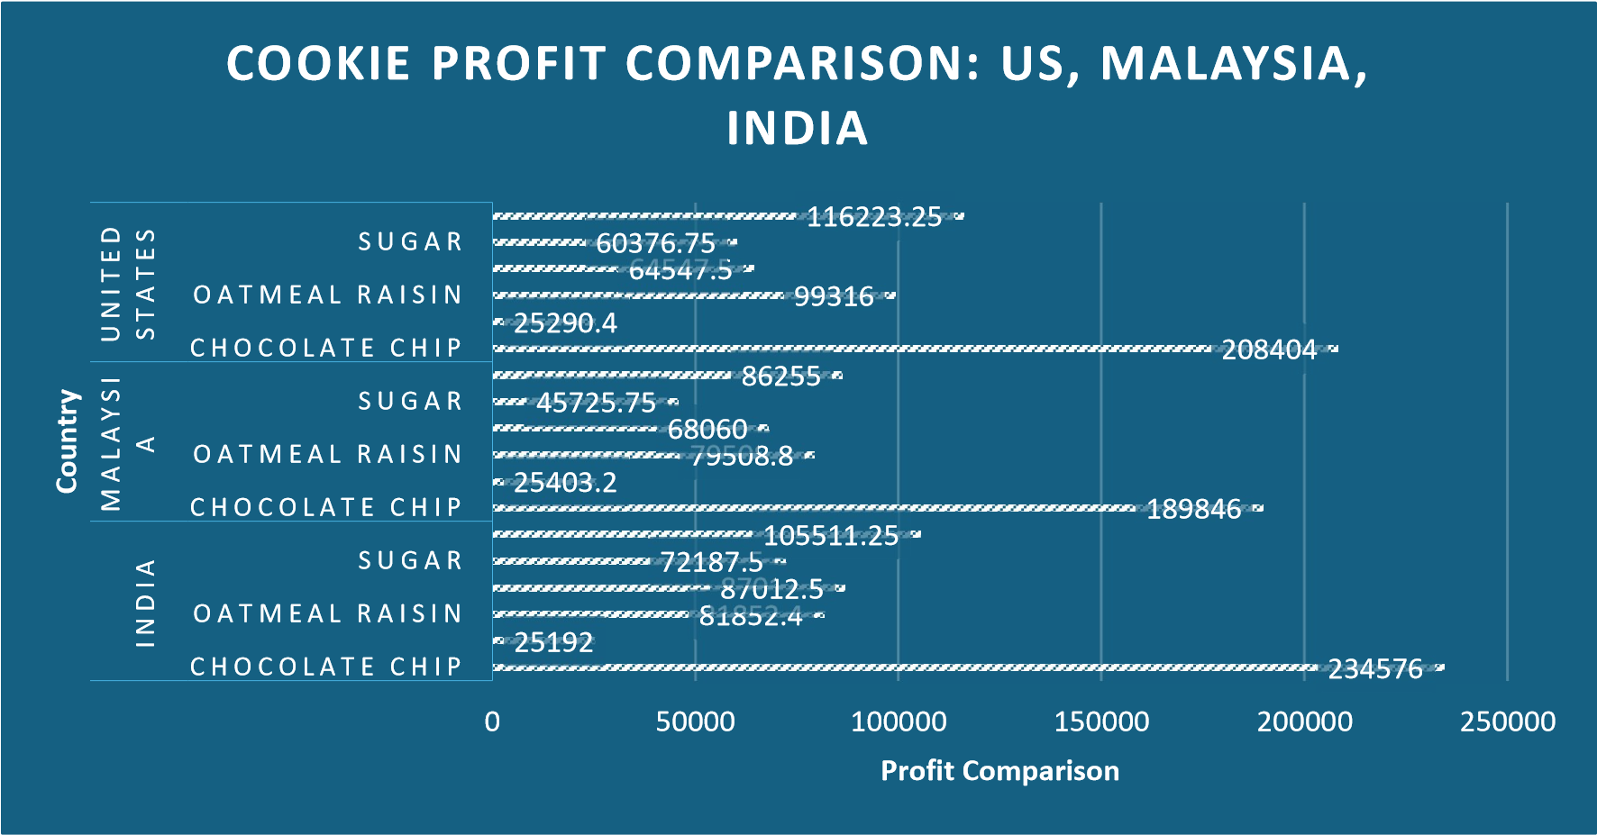

In this study, the research compares the profit margins for each type of cookie across the US, Malaysia, and India. India's profit margin for chocolate chips is the highest, followed by Malaysia and then the US.

1. What is the average revenue generated by different types of cookies?



8372.351485

1658.075269

8261.595745

6316.086022

4645.513761

8940.880734

0

1000

2000

3000

4000

5000

6000

7000

8000

9000

10000

Chocolate Chip Fortune Cookie Oatmeal Raisin Snickerdoodle

Sugar White Chocolate

Macadamia Nut

Revenue

Cookie Types

Visualizing Average Cookie Revenue

This analysis aims to provide average revenue generated and it’s visible that white chocolate macadamia nut with average revenue generate is 8940.88 followed by chocolate chip.

1. Which country sold most Fortune and sugar cookies in 2019 and in 2020?

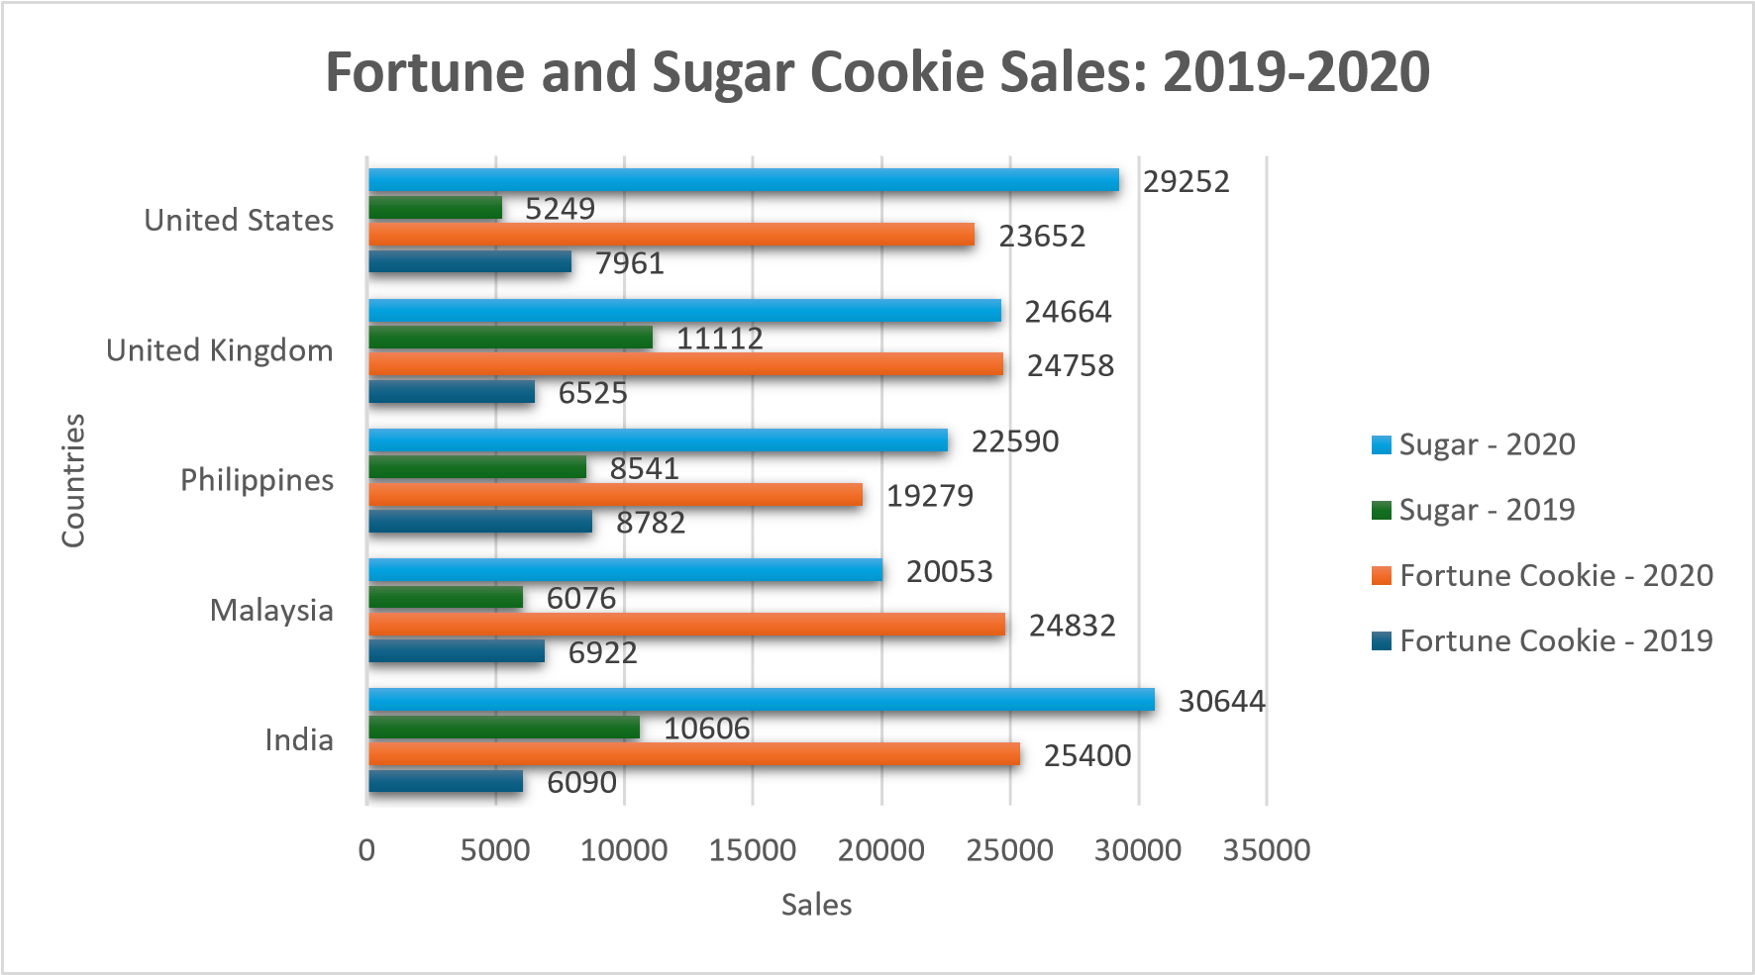

This analysis compares the sales of fortune and sugar cookies in the various countries for the years 2019 and 2020. India leads the way in significant sales of sugar cookies for the year 2020, with 30644 sales; the United Kingdom led the way in sales of sugar cookies in 2019.

India again leads in sales of fortune cookies, with 25400, followed by Malaysia; the Philippines lead in sales of fortune cookies, with 8782, followed by the United States.

1. Compare the performance of all the countries for the year 2019 to 2020. Which country perform in each of these years?

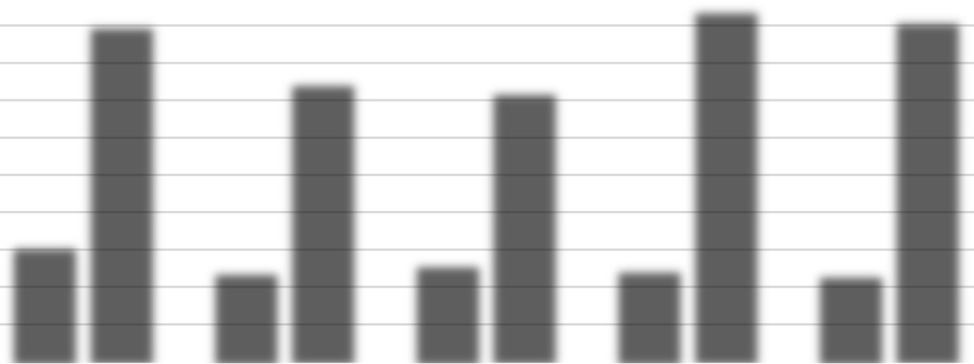

155515.5

121301.25

8

131474.

124044.0

5

117318.5

5

450816.15

373497.5

361529.75

471027.55

456839.35

0

50000

100000

150000

200000

250000

300000

350000

400000

450000

500000

India

Malaysia

Philippines United Kingdom United States

Profits

Country

Country Profit Comparison: 2019 vs 2020



2019

2020

This analysis compares the profits made by the various countries in the fiscal years 2019 and 2020. The graph indicates that the United Kingdom made the most profit in 2020 with sales of 471027.55, followed by the United States with 456839.35, and that India made the most profit in 2019 with sales of 155515.5, followed by the Philippines with 131474.8.

1. Which cookie category sold on the highest price, country wise and how much profit is earned by that category overall?

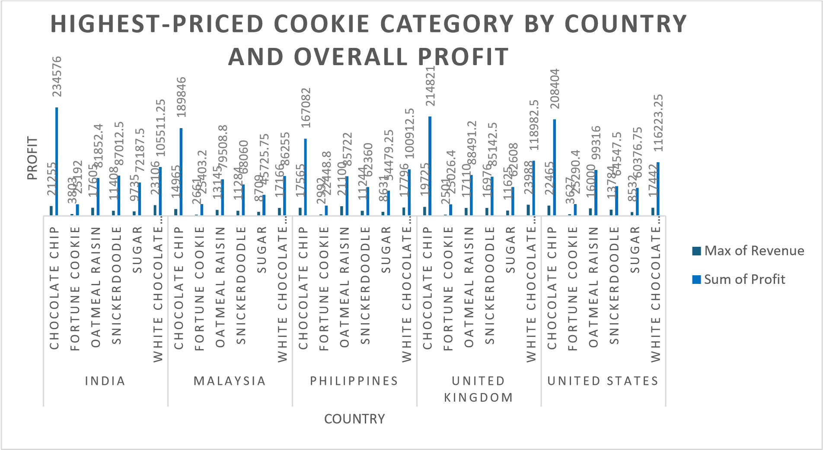

This analysis aims to find the cookie category sold for the highest price, country-wise, profit earned by that category, max of revenue is recorded by chocolate chip (23988) and sum of profit is recorded by sugar (2763364.45) for the country India followed by United Kingdom.

### Conclusion and Review

The study shed light on the profits made by several cookie varieties in the US, Malaysia, and India. The country that made the most money from chocolate chip cookies was India, followed by Malaysia and the US.

The cookies with the greatest average revenue were white chocolate macadamia nut cookies, closely followed by chocolate chip cookies.

In terms of sales, the United Kingdom led the world in sugar cookie sales in 2019, with India showing notable sales in 2020. Sales of fortune cookies were increasing in both years in Malaysia and India, with significant sales also coming from the US and the Philippines.

In terms of comparing profits by nation for 2019 and 2020, the United States and the United Kingdom both had the greatest profits in 2020. India and the Philippines had the biggest profits in 2019.

In terms of income, chocolate chip cookies brought in the most money, but altogether, sugar cookies made the most profit.

The report helped players understand market dynamics and make wise decisions by providing insightful information on the cookie sector. Visuals that were acceptable and easy to understand were used to successfully explain the findings. It's crucial to recognize the need for more research into other variables affecting sales and profitability, though. For trustworthy insights, data completeness and correctness must be guaranteed.

Regression:

Regression shows.

|  |  |
| --- | --- |
| SUMMARY OUTPUT | |
|  |  |
| Regression Statistics | |
| Multiple R | 1 |
| R Square | 1 |
| Adjusted R Square | 1 |
| Standard Error | 9.16E-12 |
| Observations | 700 |

|  |  |  |  |  |  |  |  |  |
| --- | --- | --- | --- | --- | --- | --- | --- | --- |
| ANOVA |  | | |  | |  |  |  |
|  | df | | | SS | | MS | F | Significance F |
| Regression | 3 | | | 4.78E+09 | | 1.59E+09 | 1.9E+31 | 0 |
| Residual | 696 | | | 5.84E-20 | | 8.39E-23 |  |  |
|  |  | | |  | |  |  |  |
| Total | |  | 699 | | 4.78E+09 | | | |

|  |  |  |  |  |  |  |  |  |
| --- | --- | --- | --- | --- | --- | --- | --- | --- |
|  | Coefficients | Standard Error | t Stat | P-value | Lower 95% | Upper 95% | Lower  95.0% | Upper  95.0% |
| Intercept | -1.3E-11 | 7.3E-13 | -18.0657 | 4.09E-60 | -1.5E-11 | -1.2E-  11 | -1.5E-11 | -1.2E-11 |
| X Variable 1 | 6.56E-17 | 8.42E-16 | 0.077892 | 0.937936 | -1.6E-15 | 1.72E-  15 | -1.6E-15 | 1.72E-  15 |
| X Variable 2 | 1 | 8.38E-16 | 1.19E+15 | 0 | 1 | 1 | 1 | 1 |
| X Variable 3 | -1 | 1.72E-15 | -5.8E+14 | 0 | -1 | -1 | -1 | -1 |

The regression statistics indicate a Multiple R of 1 and an R Square of 1, indicating that the independent variables explain 100% of the variance in the dependent variable. The Adjusted R Square remains at 1 as well, confirming that this perfect fit persists even when considering the number of predictors. The standard error, nearly zero (9.16E-12), suggests almost no deviation from the regression line.

Anova: one factor:

|  |  |  |  |  |  |  |
| --- | --- | --- | --- | --- | --- | --- |
| Anova: Single Factor | |  |  |  |  |  |
|  |  |  |  |  |  |  |
| SUMMARY | |  |  |  |  |  |
| Groups | Count | Sum | Average | Variance |  |  |
| Column 1 | 700 | 1926955 | 2752.792 | 4149401 |  |  |
| Column 2 | 700 | 2763364 | 3947.664 | 6842519 |  |  |
|  |  |  |  |  |  |  |
|  |  |  |  |  |  |  |
| ANOVA |  |  |  |  |  |  |
| Source of Variation | SS | df | MS | F | P-value | F crit |
| Between Groups | 5E+08 | 1 | 5E+08 | 90.92153 | 6.36E-  21 | 3.848119 |
| Within Groups | 7.68E+09 | 1398 | 5495960 |  |  |  |
|  |  |  |  |  |  |  |
| Total | 8.18E+09 | 1399 |  |  |  |  |

The ANOVA single-factor analysis compares two groups, Column 1 and Column 2, each consisting of 700 observations. Column 1 has an average value of 2752.792 and a variance of 4149401, while Column 2 exhibits a higher average of 3947.664 and a variance of 6842519. The ANOVA results reveal a significant difference between the groups, with an F-value of 90.92153, exceeding the critical value (F crit) of 3.848119. The very low p-value (6.36E-21) suggests that the differences in means are statistically significant, indicating that the variations in the groups' means are not attributable to random chance.

Anova: two factors:

|  |  |  |  |  |  |  |  |  |  |  |  |
| --- | --- | --- | --- | --- | --- | --- | --- | --- | --- | --- | --- |
| Anova: Two-Factor Without Replication | | | | | | |  | |  | |  |
|  |  | |  | |  | |  | |
| SUMMARY | Count | | Sum | | Average | | Variance | |
| Row 1 | 3 | | 17250 | | 5750 | | 6943125 | |
| Row 2 | 3 | | 21520 | | 7173.333 | | 10805909 | |
| Row 3 | 3 | | 23490 | | 7830 | | 12874869 | |
| Row 4 | 3 | | 12280 | | 4093.333 | | 3518629 | |
| Row 5 | 3 | | 13890 | | 4630 | | 4501749 | |
| Column 1 | 700 | | 4690319 | | 6700.456 | | 21380458 | |
| Column 2 | 700 | | 1926955 | | 2752.792 | | 4149401 | |
| Column 3 | 700 | | 2763364 | | 3947.664 | | 6842519 | |
|  |  | |  | |  | |  | |
| ANOVA | |  | |  | |  | |  |  |  |  |
| Source of Variation | | SS | | df | | MS | | F |  | P-value | F crit |
| Rows | | 1.99E+10 | | 699 | | 28507277 | | 14.75 | 112 | 0 | 1.112595 |
| Columns | | 5.74E+09 | | 2 | | 2.87E+09 | | 1484. | 458 | 0 | 3.002161 |
| Error | | 2.7E+09 | | 1398 | | 1932550 | |  |  |  |  |
|  | |  | |  | |  | |  |  |  |  |
| Total | | 2.84E+10 | | 2099 | |  | |  |  |  |  |

The ANOVA two-factor without replication analysis compares the means of rows and columns for a dataset with three observations per row. The summary statistics reveal variability in averages and variances across both rows and columns. The ANOVA results indicate significant differences in both rows and columns.

For rows, the F-value is 14.75112, surpassing the critical value (F crit) of 1.112595, and a p-value of 0, demonstrating significant variation between row means. Similarly, for columns, the F-value is 1484.458, significantly exceeding the critical value of 3.002161, with a p-value of 0, indicating significant differences between column means.

The substantial F-values and zero p-values suggest that the differences in both row and column means are highly significant and not attributable to random chance.

Descriptive Statistics:

|  |  |  |  |  |  |  |  |
| --- | --- | --- | --- | --- | --- | --- | --- |
| Column1 |  | Column2 |  | Column3 |  | Column4 |  |
|  |  |  |  |  |  |  |  |
| Mean | 1608.32 | Mean | 6700.456 | Mean | 2752.792 | Mean | 3947.664 |
| Standard Error | 32.78652 | Standard Error | 174.767 | Standard Error | 76.99166 | Standard Error | 98.86874 |
| Median | 1542.5 | Median | 5871.5 | Median | 2423.6 | Median | 3424.5 |
| Mode | 727 | Mode | 8715 | Mode | 3450 | Mode | 5229 |
| Standard Deviation | 867.4498 | Standard Deviation | 4623.901 | Standard Deviation | 2037.008 | Standard Deviation | 2615.821 |
| Sample Variance | 752469.1 | Sample Variance | 21380458 | Sample Variance | 4149401 | Sample Variance | 6842519 |
| Kurtosis | -0.31491 | Kurtosis | 0.464596 | Kurtosis | 0.810043 | Kurtosis | 0.338621 |
| Skewness | 0.43627 | Skewness | 0.867861 | Skewness | 0.930442 | Skewness | 0.840484 |
| Range | 4293 | Range | 23788 | Range | 10954.5 | Range | 13319 |
| Minimum | 200 | Minimum | 200 | Minimum | 40 | Minimum | 160 |
| Maximum | 4493 | Maximum | 23988 | Maximum | 10994.5 | Maximum | 13479 |
| Sum | 1125824 | Sum | 4690319 | Sum | 1926955 | Sum | 2763364 |
| Count | 700 | Count | 700 | Count | 700 | Count | 700 |

The descriptive statistics for four columns of data summarize the central tendency and variability within each column. Column 1 has a mean of 1608.32, with a standard deviation of 867.45, indicating moderate variability. Column 2 has a much higher mean of 6700.456 and a larger standard deviation of 4623.901, showing greater spread. Column 3's mean is 2752.792, with a standard deviation of 2037.008, and Column 4 has a mean of 3947.664 with a standard deviation of 2615.821, both showing significant variability. All columns exhibit positive skewness and kurtosis values near zero, indicating slightly skewed distributions with moderate tail heaviness. The ranges and sums further highlight the differences in data spread and total values across the columns, with Column 2 having the highest variability and total sum. Each column has 700 observations, ensuring a consistent sample size for comparison.

Correlation:

|  |  |  |  |  |
| --- | --- | --- | --- | --- |
|  | Column 1 | Column 2 | Column 3 | Column 4 |
| Column 1 | 1 |  |  |  |
| Column 2 | 0.796298 | 1 |  |  |
| Column 3 | 0.742604 | 0.992011 | 1 |  |
| Column 4 | 0.829304 | 0.995163 | 0.974818 | 1 |

The correlation matrix shows the strength and direction of linear relationships between four columns of data. Column 1 is moderately to strongly correlated with the other columns, with correlation coefficients of 0.796 with Column 2, 0.743 with Column 3, and 0.829 with Column 4. Columns 2, 3, and 4 exhibit very strong positive correlations among themselves, with coefficients of 0.992 between Columns 2 and 3, 0.995 between Columns 2 and 4, and 0.975 between Columns 3 and 4. These high values indicate that as one of these columns increases, the others tend to increase as well, suggesting a strong linear relationship between these sets of data.

## Loan Data Report

### Introduction

The loan dataset includes a wealth of information about loan applicants, including details about their income, property area, gender, marital status, education level, and loan amount. This dataset provides a wealth of information on loan application behaviour.

Our goal in this research is to examine the traits of loan candidates and look for trends in the data. We use pivot tables and charts to try to answer certain questions about the educational backgrounds, loan amounts, and demographics of loan applicants.

Financial institutions must comprehend the subtleties of loan applications in order to make well-informed judgments, streamline the lending process, and customize services to satisfy the wide range of client demands. Our goal in doing this research is to find practical insights that can inform strategic choices and improve the effectiveness of loan management programs.

### Questionnaire

1. How many male graduates who are not married applied for Loan? What was the highest amount?
2. How many female graduates who are not married applied for Loan? What was the highest amount?
3. How many male non-graduates who are not married applied for Loan? What was the highest amount?
4. How many female graduates who are married applied for Loan? What was the highest amount?
5. How many male and female who are not married applied for Loan? Compare Urban, Semiurban and rural based on amount.

### Analytics

1. How many male graduates who are not married applied for Loan? What was the highest amount?



66

240

0

50

100

150

200

250

300

Total

LOAN

Highest Loan Amount for Unmarried Male

Graduates



Max of LoanAmount



Count of Loan_ID

This analysis shows the no. of male graduates applied for the loan and are not married with the highest amount. As of analysed the total no. of loan applied is 66 and max loan amount is 240.

1. How many female graduates who are not married applied for Loan? What was the highest amount?



35

300

0

50

100

150

200

250

300

350

Total

TOTAL

LOAN

Loan Applications by Unmarried Female Graduates



Count of Loan_ID



Max of LoanAmount

According to this data, the greatest number of female graduates who are single sought for loans. As of now, there have been 35 total loan applications, with a maximum loan amount of $300.

1. How many male non-graduates who are not married applied for Loan? What was the highest amount?

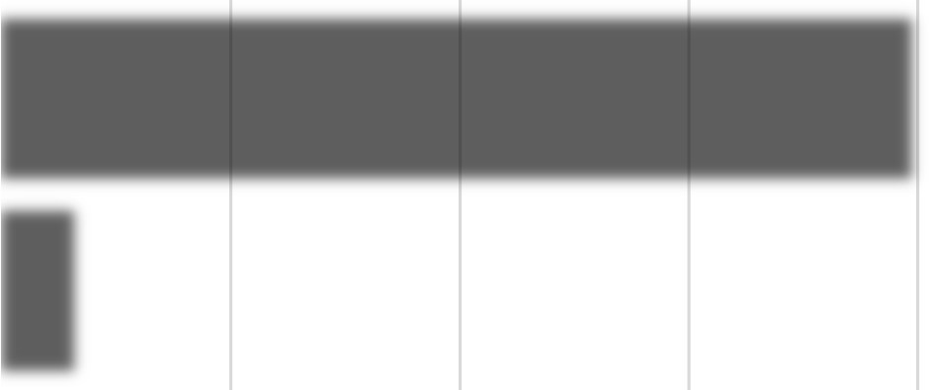

16

199

Total

0

50

100

150

200

250

TOTAL

LOAN

Loan Applications by Unmarried Male Non-

Graduates



Max of LoanAmount

Count of Loan_ID

This research reveals the number of unmarried male non-graduates who asked for loans and the greatest amount they were denied. As of now, there have been 16 total loan applications, with a maximum loan amount of 199.

1. How many female graduates who are married applied for Loan? What was the highest amount?



21

460

0

50

100

150

200

250

300

350

400

450

500

Total

No. Of Loan Application

Loan Applications by Married Female Graduates

Count of Loan_ID

Max of LoanAmount

According to this data, the greatest number of female graduates who are single sought for loans. As of now, there have been 21 total loan applications, with a maximum loan amount of $460.

1. How many males and female who are not married applied for Loan? Compare Urban, Semi-urban and rural based on amount.

|  |  |  |  |  |  |  |  |  |  |  |  |  |  |  |  |  |  |  |
| --- | --- | --- | --- | --- | --- | --- | --- | --- | --- | --- | --- | --- | --- | --- | --- | --- | --- | --- |
| Loan Applications by Unmarried Individuals, Male and Female  4000  3359 3451   |  |  | | --- | --- | |  | | |  | | | 1732 1806 1716 | | |  | | |  | | |  | | |  | | | Rural Semiurban Urban | Rural Semiurban Urban | | Female | Male |   3500 3244  Loan Application  3000  2500  2000  1500  1000  500 0  Male & Female |

This research compares unmarried male and female applicants for loans in rural, semi-urban, and metropolitan areas; the number of applications for loans is much larger in males than in females.

Loan counts for women are as follows: women's (1732), semi urban (1806), and urban (1716); men's (3244), semi urban (3359), and urban (3451).

### Conclusion and Review

|  |  |  |  |  |  |  |  |  |
| --- | --- | --- | --- | --- | --- | --- | --- | --- |
| SUMMARY  OUTPUT |  |  |  |  |  |  |  |  |
|  |  |  |  |  |  |  |  |  |
| Regression Statistics | |  |  |  |  |  |  |  |
| Multiple R | 0.531078663 |  |  |  |  |  |  |  |
| R Square | 0.282044546 |  |  |  |  |  |  |  |
| Adjusted R Square | 0.274487121 |  |  |  |  |  |  |  |
| Standard Error | 50.85033905 |  |  |  |  |  |  |  |
| Observations | 289 |  |  |  |  |  |  |  |

The data shows glaring differences in loan applications based on gender. The application pool was dominated by single male grads, then single female graduates. Though in lower percentages, married female grads and unmarried male graduates also asked for loans. Interestingly, in rural, semi-urban, and urban regions, the number of men was far more than that of girls.

The research offers insightful information on borrower demographics and successfully depicts patterns in loan applications depending on gender. It is advised to carry out more research on the variables impacting loan choices and to improve the data presentation through visual improvements. In general, the paper provides a basis for comprehending loan dynamics, with need for further analysis.

### Regression

|  |  |  |  |  |  |  |  |  |
| --- | --- | --- | --- | --- | --- | --- | --- | --- |
|  |  |  |  |  |  |  |  |  |
| ANOVA |  |  |  |  |  |  |  |  |
|  | df | SS | MS | F | Significance F |  |  |  |
| Regression | 3 | 289502.8035 | 96500.93 | 37.32019 | 2.25609E-20 |  |  |  |
| Residual | 285 | 736940.7397 | 2585.757 |  |  |  |  |  |
| Total | 288 | 1026443.543 |  |  |  |  |  |  |
|  |  |  |  |  |  |  |  |  |
|  | Coefficients | Standard Error | t Stat | P-value | Lower 95% | Upper 95% | Lower  95.0% | Upper  95.0% |
| Intercept | 66.690952 | 16.26833015 | 4.099434 | 5.41E-05 | 34.66963005 | 98.71227396 | 34.66963 | 98.71227 |
| X Variable 1 | 0.095771273 | 0.045649816 | 2.097955 | 0.03679 | 0.005917708 | 0.185624838 | 0.005918 | 0.185625 |
| X Variable 2 | 0.005807787 | 0.000627861 | 9.250122 | 5.49E-18 | 0.004571955 | 0.007043619 | 0.004572 | 0.007044 |
| X Variable 3 | 0.006772797 | 0.001264765 | 5.354983 | 1.76E-07 | 0.004283331 | 0.009262263 | 0.004283 | 0.009262 |

The provided summary output corresponds to a regression analysis conducted on a dataset comprising 289 observations. The model's overall performance is moderate, as indicated by a multiple R of approximately 0.531. The coefficient of determination (R-squared) of 0.282 suggests that around 28% of the variability in the dependent variable can be explained by the independent variables. The ANOVA table shows that the regression model is significant, with an F-value of 37.32 and a very low p-value, indicating that the model's explanatory power is significant. The coefficients table displays the intercept and coefficients for three predictor variables (X Variable 1, X Variable 2, and X Variable 3). All three predictor variables exhibit statistically significant relationships with the dependent variable, as their p-values are very low. Specifically, for every unit increase in X Variable 1, the dependent variable increases by approximately 0.096 units. Similarly, a unit increase in X Variable 2 and X Variable 3 results in approximately 0.006 and 0.007 units increase in the dependent variable, respectively. Overall, these findings suggest that the predictors significantly contribute to explaining the variability in the dependent variable.

### Anova: one factor

|  |  |  |  |  |  |  |
| --- | --- | --- | --- | --- | --- | --- |
| Anova: Single Factor | |  |  |  |  |  |
|  |  |  |  |  |  |  |
| SUMMARY | |  |  |  |  |  |
| Groups | Count | Sum | Average | Variance |  |  |
| Column 1 | 289 | 39533 | 136.7924 | 3564.04 |  |  |
| Column 2 | 289 | 99032 | 342.6713 | 4310.645 |  |  |
|  |  |  |  |  |  |  |
|  |  |  |  |  |  |  |
| ANOVA |  |  |  |  |  |  |
| Source of Variation | SS | df | MS | F | P-value | F crit |
| Between Groups | 6124794 | 1 | 6124794 | 1555.565 | 8.4E-  166 | 3.857654 |
| Within Groups | 2267909 | 576 | 3937.343 |  |  |  |
|  |  |  |  |  |  |  |
| Total | 8392703 | 577 |  |  |  |  |

This single-factor ANOVA examines the impact of a categorical factor, represented by two groups (Column 1 and Column 2), on a continuous response variable. The summary statistics provide counts, sums, averages, and variances for each group. The ANOVA table indicates sources of variation: between groups and within groups. Between groups, the sum of squares (SS) is approximately 6.12 million, with a mean square (MS) of 6.12 million, and a highly significant F-value and p-value, suggesting significant differences between group means. Within groups, the SS is around 2.27 million, reflecting variability within the groups. The total SS is approximately 8.39 million. These results imply that the categorical factor significantly influences the variation in the response variable, as indicated by the large Fvalue

### Anova: two factors

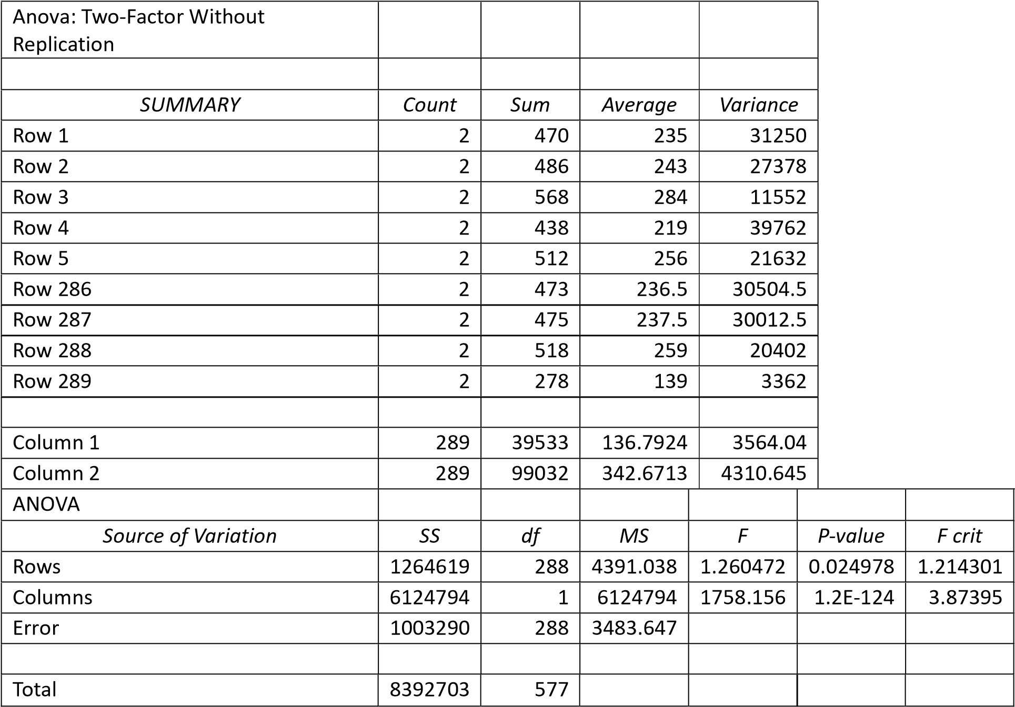

This two-factor ANOVA without replication explores the effects of two categorical factors, represented by rows and columns, on a continuous response variable. The summary statistics provide counts, sums, averages, and variances for each level of the rows and columns. The ANOVA table indicates sources of variation: rows, columns, and error. For rows, the sum of squares (SS) is approximately 1.26 million, with a mean square (MS) of 4391.038 and a significant F-value and p-value, suggesting differences between row means. For columns, the SS is substantially higher at around 6.12 million, with a highly significant F-value and a very low p-value, indicating significant differences between column means. The error term, representing variability within cells, has an SS of approximately 1.00 million. Overall, both row and column factors significantly influence the variation in the response variable, as indicated by their respective F-values and p-values.

### Descriptive Statistics

|  |  |  |  |  |  |  |  |
| --- | --- | --- | --- | --- | --- | --- | --- |
| Column1 |  | Column2 |  | Column3 |  | Column4 |  |
|  |  |  |  |  |  |  |  |
| Mean | 342.6713 | Mean | 4637.353 | Mean | 1528.263 | Mean | 136.7924 |
| Standard Error | 3.862088 | Standard Error | 281.8049 | Standard Error | 139.8588 | Standard Error | 3.51174 |
| Median | 360 | Median | 3833 | Median | 879 | Median | 126 |
| Mode | 360 | Mode | 5000 | Mode | 0 | Mode | 150 |
| Standard Deviation | 65.6555 | Standard Deviation | 4790.684 | Standard Deviation | 2377.599 | Standard Deviation | 59.69958 |
| Sample Variance | 4310.645 | Sample Variance | 22950653 | Sample Variance | 5652978 | Sample Variance | 3564.04 |
| Kurtosis | 8.62994 | Kurtosis | 141.612 | Kurtosis | 32.96701 | Kurtosis | 5.739804 |
| Skewness | -2.64147 | Skewness | 10.41123 | Skewness | 4.510775 | Skewness | 1.780616 |
| Range | 474 | Range | 72529 | Range | 24000 | Range | 432 |
| Minimum | 6 | Minimum | 0 | Minimum | 0 | Minimum | 28 |
| Maximum | 480 | Maximum | 72529 | Maximum | 24000 | Maximum | 460 |
| Sum | 99032 | Sum | 1340195 | Sum | 441668 | Sum | 39533 |
| Count | 289 | Count | 289 | Count | 289 | Count | 289 |

This table provides descriptive statistics for four variables: Column1, Column2, Column3, and Column4. Each variable's statistics are listed across rows, including measures like mean, standard error, median, mode, standard deviation, sample variance, kurtosis, skewness, range, minimum, maximum, sum, and count. For instance, Column1 has a mean of approximately 342.671, with a standard deviation of 65.655, indicating variability around the mean. Column2, however, exhibits a significantly higher mean of approximately 4637.353 and a much larger standard deviation of 4790.684, suggesting substantial variability in the data. The kurtosis values indicate the peaked Ness or flatness of the distribution, with Column2 showing extremely high kurtosis compared to the other columns. Similarly, Column3 and Column4 display their respective characteristics, such as skewness, range, and distribution shape. Overall, these statistics offer insights into the distribution, central tendency, and variability of each variable, aiding in understanding their characteristics within the dataset.

### Correlation

|  |  |  |  |
| --- | --- | --- | --- |
|  | Column  1 | Column  2 | Column  3 |
| Column  1 | 1 |  |  |
| Column  2 | -0.08435 | 1 |  |
| Column  3 | 0.445695 | 0.230355 | 1 |

The provided table represents a correlation matrix between three variables: Column 1, Column 2, and Column 3. Each cell in the matrix displays the correlation coefficient between two variables. The diagonal elements, where a variable correlates with itself, are all 1, as expected. The off-diagonal elements indicate the correlation between different pairs of variables. In this case, the correlation coefficient between Column 1 and Column 2 is approximately -0.084, suggesting a weak negative correlation. Between Column 1 and Column 3, the correlation is approximately 0.446, indicating a moderate positive correlation. Column 2 and Column 3 exhibit a correlation coefficient of approximately 0.230, suggesting a weak positive correlation between these two variables. Overall, this matrix provides insights into the relationships between the variables, with varying degrees of correlation strength observed among them.

Shop Sales Data Report

### Introduction

This report examines a large sales dataset with an emphasis on sales performance analysis and product trends among sales representatives. The collection includes features including product specifications, sales volumes, earnings, and salesman details. Finding information that can improve corporate performance and guide the creation of sales strategies is the main goal of this investigation. The report's objectives are to identify top-performing salespeople, analyze product popularity, and comprehend sales patterns by looking at sales data over a certain period of time and comparing product performance. The analysis's conclusions will be of great use to CEOs, marketing specialists, and sales managers who want to boost income, improve sales tactics, and expand their companies. Our goal in doing this study is to offer practical insights that will help inform decisions and advance the performance of the organization as a whole.

### Questionnaires

1. Compare all the salesmen based on profit earn.
2. Find out most sold product over the period of May-September.
3. Find out which of the two product sold the most over the year Computer or Laptop?
4. Which item yield most average profit?
5. Find out average sales of all the products and compare them.

### Analytics

1. Compare all the salesmen on the basis of profit earn.



414776.4447

493541.3255

476120.3887

485039.1127

478167.1413

360000

380000

400000

420000

440000

460000

480000

500000

Aman

Rahul

Ram

Rohit

Vinod

PROFIT

SALESMAN

Salesmen Ranked by Profit

When all of the salesmen are compared based on profit made, as seen by the line chart, Rahul has the most profit earned, valued at 493541.3255.

1. Find out most sold product over the period of May-September.

|  |  |  |  |  |  |
| --- | --- | --- | --- | --- | --- |
| r  Laptop  PRODUCT | Compute  153.9488594  171.4153896  155.6549194 | 179.1335546  179.9459642  180.7583737 | TOP-SELLING PRODUCT FROM MAY T  SEPTEMBER  204.2370089  224.4657315  205.9430689 | 229.3404632  252.3313782  231.0465232 | O  254.4439175  280.1970249  229.4219787 |
| MAY JU N JUL SALES AUG | | | | S EP |

We would need to examine the sales data throughout that time period in order to determine which product sold the most during the months of May through September. When the quantity sold for each product is added up for all transactions made within this time frame, the laptop is the most sold product from May to September, with the highest sales occurring in September, totaling 280.1970249.

1. Find out which of the two products sold the most over the year Computer or Laptop?



2139.876313

2358.911786

Comparison of Computer and Laptop Sales Over the

Year



Computer



Laptop

The two products that sold the most throughout the course of the year were the laptop and the computer, with the laptop having the higher sales quantity at 2358.911786 and the computer at 2139.876313.

4. Which item yield most average profit?



6770.231898

6772.950369

7057.58477

6600 6650 6700 6750 6800 6850 6900 6950 7000 7050 7100

Computer

Laptop

Mobile

PROFIT

ITEM

Average profit earned from each item.

According to this data, the mobile device has the highest average profit made (7057.58477) when compared to the laptop and computer.

5. Find out average sales of all the products and compare them.

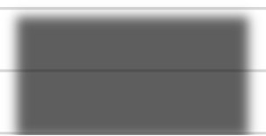

19.45342103

19.49513873

19.41876737

19.38

19.4

19.42

19.44

19.46

19.48

19.5

19.52

Computer

Laptop

Mobile

Sales

Products

average sales quantity of each product.

According to the analysis, the average sales amount of laptops (19.49513873) is larger than that of computers (19.45342103) and mobile phones (19.41876737).

Conclusion and Review:

Important information about sales effectiveness and product trends among salespeople is revealed by the analysis. Outperforming every other salesman and making the biggest profit,

Rahul comes out on top. Furthermore, the laptop is the most popular product from May to September, with September seeing the biggest sales. In terms of units sold over the course of the year, laptops do better than PCs. In addition, out of smartphones, laptops, and PCs, mobile phones have the greatest average profit. Finally, in terms of average sales quantity, laptops outperform PCs and mobile devices.

The study successfully draws attention to product trends and sales performance, offering insightful information for improving sales strategy. Visualizations help in comprehending popular products and long-term patterns. Deeper understanding of the variables affecting product preferences and sales variations, however, could improve the analysis. All things considered, the research provides useful information for enhancing sales tactics and increasing profits.

### Regression

|  |  |  |  |  |  |  |  |  |
| --- | --- | --- | --- | --- | --- | --- | --- | --- |
| SUMMARY  OUTPUT |  |  |  |  |  |  |  |  |
|  |  |  |  |  |  |  |  |  |
| Regression Statistics | |  |  |  |  |  |  |  |
| Multiple R | 0.954076972 |  |  |  |  |  |  |  |
| R Square | 0.910262868 |  |  |  |  |  |  |  |
| Adjusted R Square | 0.909998936 |  |  |  |  |  |  |  |
| Standard Error | 630.0595983 |  |  |  |  |  |  |  |
| Observations | 342 |  |  |  |  |  |  |  |
|  |  |  |  |  |  |  |  |  |
| ANOVA |  |  |  |  |  |  |  |  |
|  | df | SS | MS | F | Significance F |  |  |  |
| Regression | 1 | 1.37E+ | 1.37E+ | 3448 | 4.6E-180 |  |  |  |
| Residual | 340 | 1.35E+ | 396975 |  |  |  |  |  |
| Total | 341 | 1.5E+0 |  |  |  |  |  |  |
|  |  |  |  |  |  |  |  |  |
|  | Coefficients | Standard Error | t Stat | Pvalue | Lower 95% | Upper 95% | Lower  95.0% | Upper  95.0% |
| Intercept | 2068.993161 | 88.47952 | 23.38387 | 9.14E-  73 | 1894.957 | 2243.029 | 1894.957 | 2243.029 |
| X Variable 1 | 246.4655683 | 4.196812 | 58.72686 | 4.6E-  180 | 238.2106 | 254.7206 | 238.2106 | 254.7206 |

The regression analysis conducted on a dataset comprising 342 observations reveals a strong positive correlation between the predictor variable (X Variable 1) and the dependent variable, with a multiple R-value of 0.954. The coefficient of determination (R-squared) is 0.910, indicating that approximately 91% of the variability in the dependent variable can be explained by the predictor. The ANOVA results demonstrate a highly significant regression model, with a large F-value of 3448 and an extremely low p-value, suggesting that the model's explanatory power is significant. The coefficients table displays the intercept and coefficient for the predictor variable. Both the intercept and the coefficient for X Variable 1 are statistically significant, with respective values of 2068.99 and 246.47. These findings suggest that the predictor variable significantly contributes to explaining the variability in the dependent.

Correlation

|  |  |  |
| --- | --- | --- |
|  | Column 1 | Column 2 |
| Column 1 | 1 |  |
| Column 2 | 0.954077 | 1 |

The provided table represents a correlation matrix between two variables: Column 1 and Column 2. Each cell in the matrix displays the correlation coefficient between two variables. The diagonal elements, where a variable correlates with itself, are all 1, as expected. The offdiagonal element indicates the correlation between the two variables. In this case, the correlation coefficient between Column 1 and Column 2 is approximately 0.954, indicating a strong positive correlation between them. This implies that as values in Column 1 increase, values in Column 2 tend to increase as well, and vice versa. Overall, this matrix provides insight into the relationship between the two variables, suggesting a strong positive correlation between Column 1 and Column 2.

Anova (Single Factor):

|  |  |  |  |  |  |  |
| --- | --- | --- | --- | --- | --- | --- |
| Anova: Single Factor | |  |  |  |  |  |
|  |  |  |  |  |  |  |
| SUMMARY | |  |  |  |  |  |
| Groups | Count | Sum | Average | Variance |  |  |
| Column 1 | 342 | 6654.271 | 19.45693 | 66.0952 |  |  |
| Column 2 | 342 | 2347644 | 6864.457 | 4410782 |  |  |
|  |  |  |  |  |  |  |
|  |  |  |  |  |  |  |
| ANOVA |  |  |  |  |  |  |
| Source of Variation | SS | df | MS | F | P-value | F crit |
| Between Groups | 8.01E+09 | 1 | 8.01E+09 | 3632.879 | 2.1E-  275 | 3.85513 |
| Within Groups | 1.5E+09 | 682 | 2205424 |  |  |  |
|  |  |  |  |  |  |  |
| Total | 9.52E+09 | 683 |  |  |  |  |

This single-factor ANOVA investigates the impact of a categorical factor, represented by two groups (Column 1 and Column 2), on a continuous response variable. The summary statistics provide counts, sums, averages, and variances for each group. The ANOVA table indicates the sources of variation: between groups and within groups. The between groups sum of squares (SS) is approximately 8.01E+09, with a mean square (MS) of 8.01E+09, and a highly significant F-value and p-value, suggesting significant differences between group means. The within groups SS is around 1.5E+09, reflecting variability within the groups. The total SS is approximately 9.52E+09. These results imply that the categorical factor significantly influences the variation in the response variable, as indicated by the large F-value and significant p-value.

Anova two factor:

|  |  |  |  |  |  |  |  |  |  |  |  |
| --- | --- | --- | --- | --- | --- | --- | --- | --- | --- | --- | --- |
| Anova: Two-Factor Without Replication | | | | | | |  | |  | |  |
|  |  | |  | |  | |  | |
| SUMMARY | Count | | Sum | | Average | | Variance | |
| Row 1 | 2 | | 1003 | | 501.5 | | 497004.5 | |
| Row 2 | 2 | | 7804 | | 3902 | | 30388808 | |
| Row 3 | 2 | | 3005 | | 1502.5 | | 4485013 | |
| Row 4 | 2 | | 2304 | | 1152 | | 2635808 | |
| Row 5 | 2 | | 7003 | | 3501.5 | | 24479005 | |
| Row 339 | 2 | | 10252.82 | | 5126.411 | | 51884342 | |
| Row 340 | 2 | | 10272.93 | | 5136.467 | | 52087770 | |
| Row 341 | 2 | | 10293.05 | | 5146.523 | | 52291595 | |
| Row 342 | 2 | | 10313.16 | | 5156.58 | | 52495819 | |
|  |  | |  | |  | |  | |
| Column 1 | 342 | | 6654.271 | | 19.45693 | | 66.0952 | |
| Column 2 | 342 | | 2347644 | | 6864.457 | | 4410782 | |
| ANOVA | |  | |  | |  | |  |  |  |  |
| Source of Variation | | SS | | df | | MS | | F |  | P-value | F crit |
| Rows | | 7.58E+08 | | 341 | | 2221714 | | 1.0148 | 83 | 0.445792 | 1.195299 |
| Columns | | 8.01E+09 | | 1 | | 8.01E+09 | | 3659.9 | 13 | 2.1E-184 | 3.868873 |
| Error | | 7.46E+08 | | 341 | | 2189134 | |  |  |  |  |
|  | |  | |  | |  | |  |  |  |  |
| Total | | 9.52E+09 | | 683 | |  | |  |  |  |  |

This two-factor ANOVA without replication examines the effects of two categorical factors, represented by rows and columns, on a continuous response variable. The summary statistics provide counts, sums, averages, and variances for each level of the rows and columns. The ANOVA table presents the sources of variation: rows, columns, and error. For the rows, the sum of squares (SS) is approximately 7.58E+08, with a mean square (MS) of 2221714, and a non-significant F-value and p-value, indicating no significant difference between row means. However, for the columns, the SS is substantially higher at 8.01E+09, with a highly significant F-value and a very low p-value, suggesting significant differences between column means. The error term represents variability within cells and has an SS of approximately 7.46E+08. The total SS is approximately 9.52E+09. Overall, while there is no significant difference between row means, the column factor significantly influences the variation in the response variable.

Descriptive Statistics:

|  |  |  |  |
| --- | --- | --- | --- |
| Column1 |  | Column2 |  |
|  |  |  |  |
| Mean | 19.45693 | Mean | 6864.457 |
| Standard Error | 0.439614 | Standard Error | 113.5651 |
| Median | 19.45693 | Median | 6984.647 |
| Mode | 3 | Mode | 1000 |
| Standard Deviation | 8.129896 | Standard Deviation | 2100.186 |
| Sample Variance | 66.0952 | Sample Variance | 4410782 |
| Kurtosis | -0.99883 | Kurtosis | -0.5078 |
| Skewness | -0.09948 | Skewness | -0.36449 |
| Range | 30.30852 | Range | 9279.851 |
| Minimum | 3 | Minimum | 1000 |
| Maximum | 33.30852 | Maximum | 10279.85 |
| Sum | 6654.271 | Sum | 2347644 |
| Count | 342 | Count | 342 |

The provided table presents descriptive statistics for two variables: Column1 and Column2. For Column1, the mean is approximately 19.457, with a standard deviation of 8.130, indicating relatively low variability around the mean. Column1 also exhibits a kurtosis value close to -1, suggesting a slightly flatter distribution than the normal distribution. In contrast, Column2 has a much higher mean of approximately 6864.457 and a significantly larger standard deviation of 2100.186, indicating greater variability in the data. The kurtosis value for Column2 is also negative, indicating a slightly flatter distribution. Additionally, Column2 has a wider range, ranging from 1000 to 10279.85, compared to Column1's range of 3 to 33.30852. Overall, these statistics provide a comprehensive summary of the distribution, central tendency, and variability of each variable, aiding in understanding their characteristics and potential relationships in the dataset.

## Sales Data Sample Report

### Introduction

A large sales dataset with variables like ORDERNUMBER, QUANTITYORDERED, PRICEEACH, and SALES is analyzed in this report. It seeks to draw conclusions that will direct sales tactics and improve corporate performance. Sales managers, marketers, and executives looking to increase revenue and enhance sales processes are among the intended audience members. Important studies include comparing the sales of classic and vintage automobiles, figuring out average sales, figuring out what items are best-selling, analyzing the profit margin by nation for particular product lines, comparing sales over time, and analyzing countries according to the amount of deals. The research seeks to offer practical insights for boosting sales growth and enhancing overall business outcomes through these assessments.

The project's scope includes analyzing a sizable sales dataset in order to glean insightful information that might improve product offers, guide sales methods, and boost overall business performance. The project will be valuable to analysts and researchers who are looking for insights on market trends and sales dynamics.

### Questionnaire

1. Comparison of sales between Vintage cars and Classic cars across all countries.
2. Determination of the average sales of all products and identification of the highest-selling product.
3. Assessment of the country yielding the most profit for Motorcycles, Trucks, and Buses.
4. Comparison of sales for all items across the years 2004 and 2005.
5. Comparative analysis of all countries based on deal size.

### Analytics

1. Comparison of sales between Vintage cars and Classic cars across all countries.

382640.86

128656.95

62062.56

102136.01

178288.29

171935.24

565561.01

169250.91

33923.22

239027.39

76721.31

177808.37

55047.18

167850.9

705679.66

102892.52

117713.56

283176.44

2102394.12

500000

0

1000000

1500000

2000000

2500000

Australia

Belgium

Denmark

France

Ireland

Japan

Philippines

Spain

Switzerland

USA

Sales

Countries

Sales of Vintage cars and Classic cars

This analysis Compare the sale of Vintage cars and Classic cars for all the countries. Where USA (2102394.02) has the highest sales followed by Spain, France, and Australia.

1. Determination of the average sales of all products and identification of the highestselling product.



4053.377104

3523.831843

3186.286176

3053.150128

2938.226883

3746.8101

3135.33911

0

500

1000

1500

2000

2500

3000

3500

4000

4500

Classic Cars Motorcycles

Planes

Ships

Trucks and

Trains

Buses

Vintage Cars

SALES

PRODUCTS

Average sales of each product line.

The average sales of every product and the top-selling product are the two goals of this investigation. Additionally, the graph shows that, with an average sale of 405.377104, Classic Cars have the greatest sales, followed by Trucks and Buses and Motorcycles.

1. Assessment of the country yielding the most profit for Motorcycles, Trucks, and Buses.

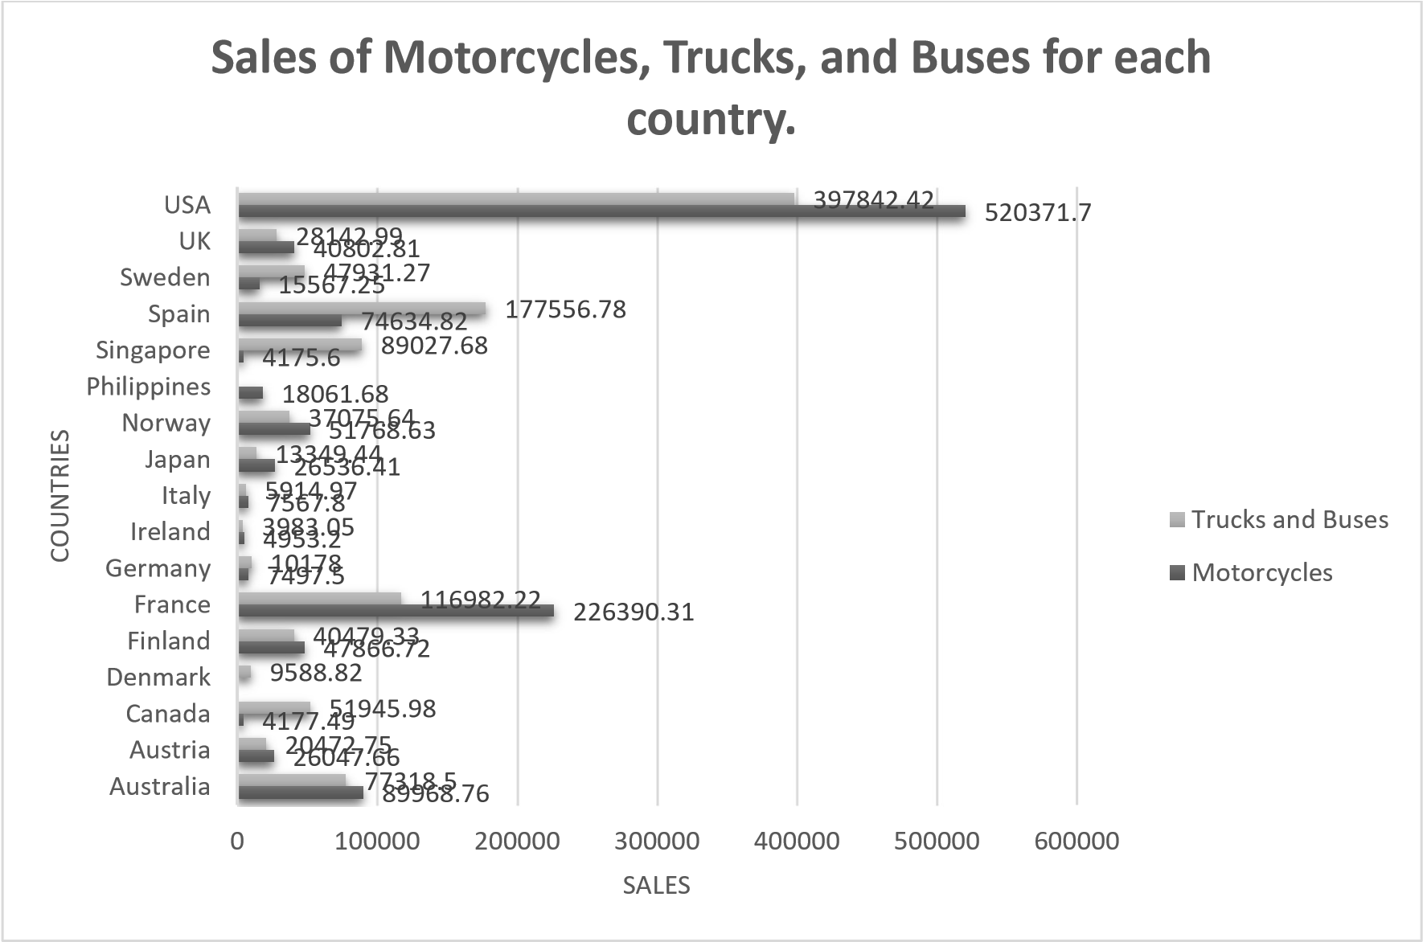

The goal of this analysis is to determine which nation makes the most money from trucks, buses, and motorcycles. According to a bar graph, the USA leads the world in motorcycle sales with 520371.7, followed by France and Spain, and the world in truck and bus sales with 397842.42.

1. Comparison of sales for all items across the years 2004 and 2005.

1762257.09

560545.23

502671.8

341437.97

23.85

1165

529302.89

911423.77

672573.28

234947.5

3

200074.

17

1281

78.07

3

6

917.3

3

057.0

2

178

340739.31

2000000

0

500000

1000000

1500000

Classic Cars

Motorcycles

Planes

Ships

Trains

Trucks and Buses

Vintage Cars

SALES

ITEMS

Sales for all items from 2004 - 2005

2005

2004

The goal of this analysis is to compare the sales of every item in the years 2004 and 2005. The line chart shows that sales of every item are changing at a very rapid rate, with the exception of classic cars, which had the highest sales of any category in both years, with 1762257.09 in 2004 and 672573.28 in 20

1. Comparative analysis of all countries based on deal size.

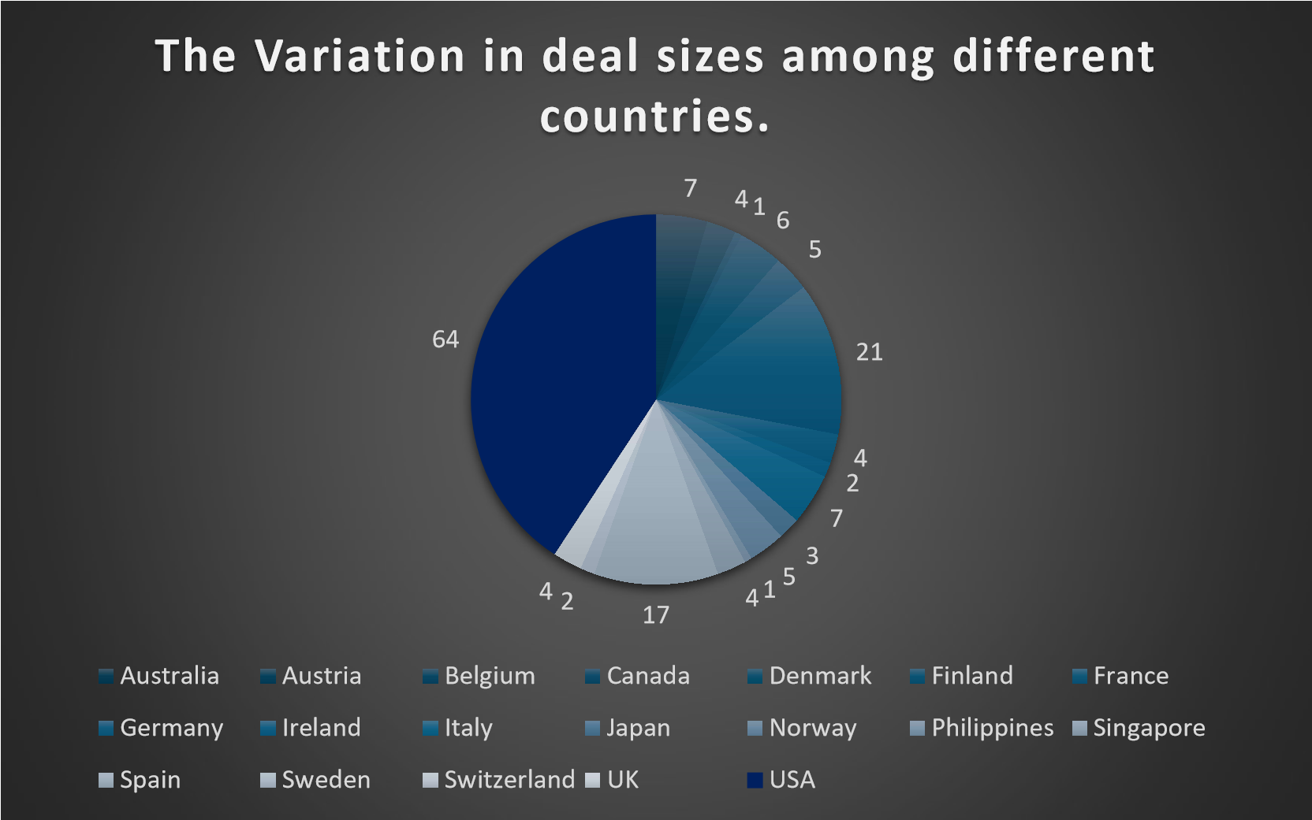

### The aim of this research is to investigate the distribution of deal sizes across different nations. Furthermore, the bar chart illustrates that the USA consistently makes significantly larger deals compared to other countries. Specifically, large deals are valued at 64, medium deals at 505, and small deals at 435.

### Conclusion and Review

The analysis provides valuable insights into sales trends and profitability by category and by country. The USA comes out on top as a market leader in Vintage & Classic cars, in Trucks, in Buses, and in Motorcycles. Classic Cars are the top-selling product, accounting for a significant portion of total sales revenue. In addition, the USA shows exceptional profitability, especially in the Trucks & Buses & Motorcycles categories. Sales for Classic cars remain strong throughout 2004 and 2005, showing that there is a continuing demand for this product category. Also, the USA shows significantly larger deal sizes than other countries, demonstrating its dominance in terms of sales volume.

While the analysis provides visualizations of key findings, more in-depth analysis into the drivers of sales volatility and deal size differences could yield more insightful results. All in all, the report provides valuable insights to optimize sales strategies and accelerate business growth.

Regression:

SUMMARY OUTPUT

|  |  |  |  |  |  |  |  |  |
| --- | --- | --- | --- | --- | --- | --- | --- | --- |
|  | |  |  |  |  |  |  |  |
| Regression Statistics | |
| Multiple R | 0.877178 |
| R Square | 0.769441 |  |  |  |  |  |  |  |
| Adjusted R Square | 0.766629 |
| Standard Error | 896.6688 |
| Observations | 250 |
|  |  |  |  |  |  |
| ANOVA |  |  |  |  |  |
|  | df | SS | MS | F | Significance F |
| Regression | 3 | 6.6E+08 | 2.2E+08 | 273.6567 | 4.62E-78 |
| Residual | 246 | 1.98E+08 | 804014.9 |  |  |
| Total | 249 | 8.58E+08 |  |  |  |
|  |  |  |  |  |  |
|  | Coefficients | Standard Error | t Stat | P-value | Lower 95% | Upper 95% | Lower  95.0% | Upper  95.0% |
| Intercept | -5271.93 | 322.9166 | -16.326 | 4.32E-41 | -5907.96 | -4635.9 | -5907.96 | -4635.9 |
| X Variable 1 | 103.0809 | 6.001152 | 17.17685 | 5.42E-44 | 91.26071 | 114.9011 | 91.26071 | 114.9011 |
| X Variable 2 | 12.81807 | 1.661734 | 7.713668 | 3.04E-13 | 9.545024 | 16.09111 | 9.545024 | 16.09111 |
| X Variable 3 | 47.42944 | 3.350938 | 14.15408 | 1.13E-33 | 40.82925 | 54.02963 | 40.82925 | 54.02963 |

The regression analysis conducted on a dataset comprising 250 observations indicates a multiple R-value of 0.877, suggesting a strong positive correlation between the predictors and the dependent variable. The R-squared value of 0.769 implies that approximately 77% of the variability in the dependent variable can be explained by the predictors. The ANOVA results reveal a highly significant regression model, with a large F-value of 273.66 and a very low p-value, indicating that the model's explanatory power is significant.

The coefficients table displays the intercept and coefficients for three predictor variables. All predictor variables, X Variable 1, X Variable 2, and X Variable 3, exhibit statistically significant relationships with the dependent variable, with respective coefficients of 103.08, 12.82, and 47.43. These findings suggest that the predictors significantly contribute to explaining the variability in the dependent variable.

Anova: one factor:

|  |  |  |  |  |  |  |
| --- | --- | --- | --- | --- | --- | --- |
| Anova: Single Factor | |  |  |  |  |  |
|  |  |  |  |  |  |  |
| SUMMARY | |  |  |  |  |  |
| Groups | Count | Sum | Average | Variance |  |  |
| Column 1 | 250 | 903280.9 | 3613.123 | 3445221 |  |  |
| Column 2 | 250 | 25534 | 102.136 | 1664.552 |  |  |
|  |  |  |  |  |  |  |
|  |  |  |  |  |  |  |

|  |  |  |  |  |  |  |
| --- | --- | --- | --- | --- | --- | --- |
| ANOVA |  |  |  |  |  |  |
| Source of Variation | SS | df | MS | F | P-value | F crit |
| Between Groups | 1.54E+09 | 1 | 1.54E+09 | 894.0704 | 3.1E-  113 | 3.860199 |
| Within Groups | 8.58E+08 | 498 | 1723443 |  |  |  |
|  |  |  |  |  |  |  |
| Total | 2.4E+09 | 499 |  |  |  |  |

This single-factor ANOVA examines the impact of a categorical factor, represented by two columns, on a continuous response variable. The summary statistics provide counts, sums, averages, and variances for each level of the factor.

The ANOVA table partitions the variation into between groups and within groups. Between groups, the sum of squares (SS) is approximately 1.54E+09, with a mean square (MS) of 1.54E+09. A highly significant F-value and p-value indicate significant differences between group means. Within groups, the SS is around 8.58E+08, reflecting variability within the groups. The total SS is approximately 2.4E+09.

These results suggest that the categorical factor significantly influences the variation in the response variable, as indicated by the large F-value and significant p-value.

Anova: two factors:

|  |  |  |  |  |  |  |  |  |  |  |  |
| --- | --- | --- | --- | --- | --- | --- | --- | --- | --- | --- | --- |
| Anova: Two-Factor Without Replication | | | | | | |  | |  |  |  |
|  |  | |  | |  | |  | |
| SUMMARY | Count | | Sum | | Average | | Variance | |
| Row 1 | 3 | | 4097.66 | | 1365.887 | | 5069957 | |
| Row 2 | 3 | | 2451.12 | | 817.04 | | 1725170 | |
| Row 3 | 3 | | 1566 | | 522 | | 648687 | |
| Row 4 | 3 | | 5095.24 | | 1698.413 | | 7507173 | |
| Row 5 | 3 | | 5140.39 | | 1713.463 | | 7650609 | |
| Row 248 | | 3 | | 4386.35 | | 1462.117 | | 5944534 | |  |  |
| Row 249 | | 3 | | 2261.6 | | 753.8667 | | 1546167 | |  |  |
| Row 250 | | 3 | | 4176.72 | | 1392.24 | | 5420980 | |  |  |
|  | |  | |  | |  | |  | |  |  |
| Column 1 | | 250 | | 903280.9 | | 3613.123 | | 3445221 | |  |  |
| Column 2 | | 250 | | 25534 | | 102.136 | | 1664.552 | |  |  |
| Column 3 | | 250 | | 8659 | | 34.636 | | 89.69428 | |  |  |
|  | |  | |  | |  | |  | |  |  |
|  | |  | |  | |  | |  | |  |  |
| ANOVA | |  | |  | |  | |  | |  |  |
| Source of Variation | | SS | | df | | MS | | F | | P-value | F crit |
| Rows | | 2.95E+08 | | 249 | | 1182944 | | 1.044989 | | 0.33951 | 1.194432 |
| Columns | | 2.09E+09 | | 2 | | 1.05E+09 | | 925.2361 | | 1.9E-  168 | 3.013826 |
| Error | | 5.64E+08 | | 498 | | 1132016 | |  | |  |  |
|  | |  | |  | |  | |  | |  |  |
| Total | | 2.95E+09 | | 749 | |  | |  | |  |  |
|  | |  | |  | |  | |  | |  |  |

This two-factor ANOVA without replication examines the effects of two categorical factors, rows and columns, on a continuous response variable. The summary statistics present counts, sums, averages, and variances for each level of the rows and columns. The ANOVA table delineates the sources of variation: rows, columns, and error. For the rows, the sum of squares (SS) is approximately 2.95E+08, with a mean square (MS) of 1182944 and a non-significant F-value and p-value, indicating no significant difference between row means. However, for the columns, the SS is substantially higher at 2.09E+09, with a highly significant F-value and a very low p-value, suggesting significant differences between column means. The error term represents variability within cells and has an SS of approximately 5.64E+08

Descriptive Statistics:

|  |  |  |  |  |  |  |  |
| --- | --- | --- | --- | --- | --- | --- | --- |
| Column1 |  | Column2 |  | Column3 |  | Column4 |  |
|  |  |  |  |  |  |  |  |
| Mean | 34.636 | Mean | 3613.123 | Mean | 102.136 | Mean | 84.45296 |
| Standard Error | 0.59898 | Standard Error | 117.392 | Standard Error | 2.58035 | Standard Error | 1.279453 |
| Median | 34 | Median | 3263.96 | Median | 99 | Median | 100 |
| Mode | 29 | Mode | #N/A | Mode | 118 | Mode | 100 |
| Standard Deviation | 9.470706 | Standard Deviation | 1856.131 | Standard Deviation | 40.79892 | Standard Deviation | 20.22993 |
| Sample Variance | 89.69428 | Sample Variance | 3445221 | Sample Variance | 1664.552 | Sample Variance | 409.2499 |
| Kurtosis | -0.64676 | Kurtosis | 1.127057 | Kurtosis | -0.19836 | Kurtosis | -0.40344 |
| Skewness | 0.256745 | Skewness | 1.013489 | Skewness | 0.517104 | Skewness | -0.9678 |
| Range | 51 | Range | 10626.85 | Range | 181 | Range | 73.12 |
| Minimum | 15 | Minimum | 652.35 | Minimum | 33 | Minimum | 26.88 |
| Maximum | 66 | Maximum | 11279.2 | Maximum | 214 | Maximum | 100 |
| Sum | 8659 | Sum | 903280.9 | Sum | 25534 | Sum | 21113.24 |
| Count | 250 | Count | 250 | Count | 250 | Count | 250 |

This table presents descriptive statistics for four variables: Column1, Column2, Column3, and Column4. Each variable's statistics are listed across rows, including measures like mean, standard error, median, mode, standard deviation, sample variance, kurtosis, skewness, range, minimum, maximum, sum, and count.

For instance, Column1 has a mean of approximately 34.636 and a standard deviation of 9.471, indicating variability around the mean. Column2, with a mean of approximately 3613.123 and a standard deviation of 1856.131, shows much higher variability compared to the other columns. Column3 and Column4 display means of around 102.136 and 84.453, respectively, with moderate standard deviations.

The skewness and kurtosis values provide insights into the distribution's shape and tail behavior for each variable. Overall, these statistics offer a comprehensive summary of the distribution, central tendency, and variability of each variable, aiding in understanding their characteristics and potential relationships in the dataset.

Correlation:

|  |  |  |  |
| --- | --- | --- | --- |
|  | Column  1 | Column  2 | Column  3 |
| Column | 1 |  |  |
| 1 |  |  |  |
| Column  2 | 0.513951 | 1 |  |
| Column  3 | -0.01254 | 0.663973 | 1 |

The provided table represents a correlation matrix between three variables: Column 1, Column 2, and Column 3. Each cell in the matrix displays the correlation coefficient between two variables. The diagonal elements, where a variable correlates with itself, are all 1, as expected.

The off-diagonal elements indicate the correlation between different pairs of variables. For instance, the correlation between Column 1 and Column 2 is approximately 0.514, suggesting a moderate positive correlation. Similarly, the correlation between Column 1 and Column 3 is close to zero at -0.013, indicating a weak negative correlation. Column 2 and Column 3 exhibit a correlation of approximately 0.664, indicating a moderate positive correlation between these two variables.

Overall, this matrix provides insight into the relationships between the variables, with varying degrees of correlation strength observed among them.

## Store Dataset Report

### Introduction

This dataset contains sales data from a retail store. It includes things like gender, age, transaction details (order ID, status), product details (category, SKU) and shipping details. Our goal is to help you understand how your customers interact with your products and how they interact with your products. We look for patterns, preferences and correlations within your data. With these insights, you can improve your marketing, manage your inventory and increase your customer satisfaction.

### Questionnaire

1. Compare various channels based on how many male customers order and female customer order.
2. Compare all the categories of order where amount is less than 1500 and greater than 5000.
3. How many Customers are there whose age is 30 and above and state is Delhi.
4. Which of the following state perform better than other, Delhi, Tamil Nadu, Maharashtra, Rajasthan.
5. Which city performed better than all other cities based on highest order placed.
6. Compare various categories of items based on most quantity sold and show which gender buys the most category.

### Analytics

1. Compare various channels based on how many male customers order and female customer order?

57

9

343

2

204

3

39

5

215

6

45

4

39

3

134

4

7547

3

464

3

99

2

506

6

102

864

0

1000

2000

3000

4000

5000

6000

7000

8000

Amazon

Flipkart

Meesho

Myntra

Nalli

Others

Ajio

Orders

Shopping Sites

Channel Comparison: Male vs Female Orders

Men

Women

Sales for both men and women are led by Amazon, which is followed by Myntra and Flipkart. Nearly 3432 units were sold by Amazon in the men's category, and nearly 7547 units in the women's category. 5062 units were sold in the women's area of Myntra, and 2156 units in the men.

1. Compare all the categories of order where amount is less than 1500 and greater than 5000.

229

78

264

10446

1380

12391

2193

4066

0

2000

4000

6000

8000

10000

12000

14000

Blouse

Bottom

Ethnic

Dress

Saree

Set

Top

Western

kurta

Dress

AMOUNT

PRODUCT

Comparison of Order Categories: $500 - $1500

vs. > $5000

Comparing the order categories where the quantity is less than 1500 and more than 5000 is made easier by this analysis. displaying the set (12391) and kurta (10446) with the greatest order count, followed by the saree, top, and western attire.

1. Which of the following state perform better than other, Delhi, Tamil Nadu, Maharashtra, Rajasthan?

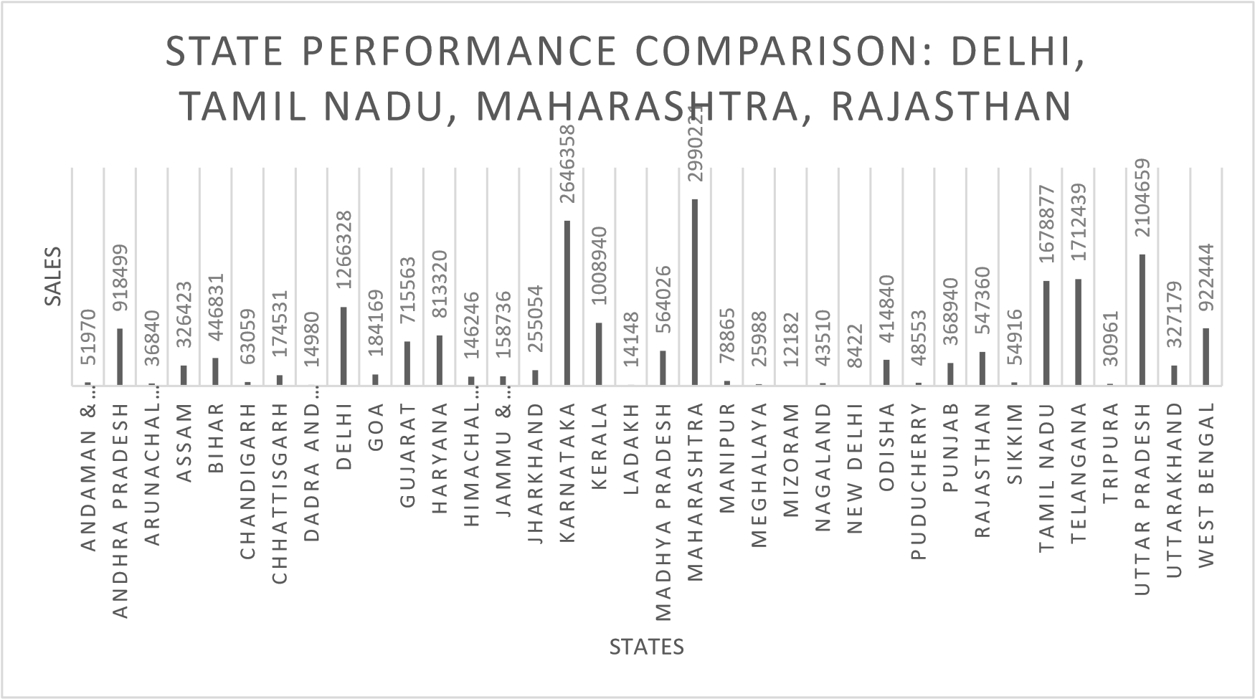

Karnataka (2646358) had the best performance among the states, followed by Uttar Pradesh (2104659). This research reveals which states fared better than the states indicated above.

1. Which city performed better than all other cities based on highest order placed.

2673

1468

1998

696

480

1402

1684

863

0

500

1000

1500

2000

2500

3000

Abohar

AMBALA CITY

ARSIKERE

Balasore

BARUIPUR

BHARUCH

BODHAN

CHANNAPATNA

Chorao

DEOGHAR

Dist una

FARAKKA

GIRIDIH

HALDWANI

HUGLI CHINSURAH

JAMUHAN

Kalaiyanur, coimbatore

KARANJIA

KHARAGPUR

KOTTARAKKARA

LALITPUR

MALIKIPURAM

Mavelikkara

MULLASSERY

Naharlugun model…

Neemrana

PACHORA

Parbhani

PILICODE

PURANATTUKARA

RANGPO

SAHARANPUR

SHAHDOL

SIRSA

Tadepalli

THENI ALLINAGARAM

Trichy

VAIJAPUR

VIRALIMALAI

ORDERS

CITY

Top-Performing City Based on Highest

Order Placement

Bengaluru had the largest order put with 2673 orders, followed by Hyderabad (1998). Based on the graph recorded, we can really observe which city fared better than the other cities based on biggest order placed.

1. Compare various categories of items based on most quantity sold and also show which gender buys the most category.

|  |  |  |  |  |  |  |  |  |  |  |  |  |  |  |  |  |  |  |  |  |  |  |
| --- | --- | --- | --- | --- | --- | --- | --- | --- | --- | --- | --- | --- | --- | --- | --- | --- | --- | --- | --- | --- | --- | --- |
| Item Category Comparison: Quantity Sold &  Dominant Gender Buyer   |  |  |  |  |  |  |  |  |  |  |  |  |  |  |  |  |  |  |  |  |  |  | | --- | --- | --- | --- | --- | --- | --- | --- | --- | --- | --- | --- | --- | --- | --- | --- | --- | --- | --- | --- | --- | --- | | |  |  |  |  |  |  |  |  |  |  |  |  | | --- | --- | --- | --- | --- | --- | --- | --- | --- | --- | --- | --- | | 7225 | 4632 | 17688 | 103 | | 06  108  289 | | 726 | | 0  2144  49 | 3606 | | | 174 |  | | 513  8 | 9 | |  | 459 | |  |  | |  |   12000  10000 8000  6000  SALES  4000Men  Women  2000  0  Blouse Bottom Ethnic kurta Saree Set Top Western  Dress Dress  ITEM CATEGORY |

The kurta purchased by women is the most popular category of things, followed by men's purchases, and western clothing is the most popular item for both men and women. This report compares these different product categories based on sales volume.

### Conclusion and Review

Amazon leads in sales for both men and women, according to the research, with Myntra and Flipkart trailing closely after. Sales for both men's and women's categories are led by Amazon, which is followed by Myntra and Flipkart. Kurtas and sets are among the bestselling products; Karnataka and Bangalore have the best sales figures.

Retailers may make better decisions thanks to the study, which offers insightful information about regional performance and sales patterns. Nonetheless, the analysis may be improved by looking at other variables that affect sales. All things considered, the results provide insightful knowledge for maximizing sales tactics in cutthroat marketplaces.

Regression:

|  |  |  |  |  |  |  |  |  |
| --- | --- | --- | --- | --- | --- | --- | --- | --- |
| SUMMARY OUTPUT | |  |  |  |  |  |  |  |
| Regression Statistics | |
| Multiple R | 0.172398 |
| R Square | 0.029721 |
| Adjusted R Square | 0.029659 |
| Standard Error | 264.5693 |
| Observations | 31047 |
|  |  |
| ANOVA |  |
|  | df | SS | MS | F | Significance F |
| Regression | 2 | 66561870 | 33280935 | 475.4629 | 0 |
| Residual | 31044 | 2.17E+09 | 69996.92 |  |  |
| Total | 31046 | 2.24E+09 |  |  |  |
|  |  |  |  |  |  |
|  | Coefficients | Standard Error | t Stat | P-value | Lower 95% | Upper 95% | Lower  95.0% | Upper  95.0% |
| Intercept | 185.155 | 16.57854 | 11.16836 | 6.61E-29 | 152.6604 | 217.6496 | 152.6604 | 217.6496 |
| X Variable 1 | 0.047626 | 0.099327 | 0.479489 | 0.631594 | -0.14706 | 0.242312 | -0.14706 | 0.242312 |
| X Variable 2 | 492.0276 | 15.95904 | 30.83065 | 1.3E-205 | 460.7472 | 523.308 | 460.7472 | 523.308 |

The regression analysis conducted on the dataset comprising 31,047 observations indicates a multiple R-value of 0.172, suggesting a weak positive correlation between the predictors and the dependent variable. The R-squared value of 0.030 implies that only about 3% of the variability in the dependent variable can be explained by the predictors.

The ANOVA results reveal a significant regression model, with a large F-value of 475.46 and a corresponding p-value of 0. Additionally, the coefficients table displays the intercept and coefficients for two predictor variables. Both X Variable 1 and X Variable 2 exhibit statistically significant relationships with the dependent variable, with respective coefficients of 0.048 and 492.028.

These findings suggest that while there is a statistically significant relationship between the predictors and the dependent variable, the overall explanatory power of the model remains relatively low.

Anova-1 factor:

|  |  |  |  |  |
| --- | --- | --- | --- | --- |
| Anova: Single Factor | |  |  |  |
| SUMMARY | |  |  |  |
| Groups | Count | Sum | Average | Variance |
| Column 1 | 31047 | 31237 | 1.00612 | 0.008853 |
| Column 2 | 31047 | 21176377 | 682.0748 | 72136.38 |
|  |  |  |  |  |
|  |  |  |  |  |
| ANOVA |  |  |  |  |
| Source of Variation | SS | df | MS | F |
| Between Groups | 7.2E+09 | 1 | 7.2E+09 | 199639.8 |
| Within Groups | 2.24E+09 | 62092 | 36068.2 |  |
|  |  |  |  |  |
| Total | 9.44E+09 | 62093 |  |  |

This single-factor ANOVA examines the impact of a categorical factor, represented by two columns, on a continuous response variable. The summary statistics reveal that Column 1 has a mean of approximately 1.006 and a very small variance, while Column 2 exhibits a significantly higher mean of about 682.075 with a larger variance. The ANOVA results indicate a highly significant difference between the groups, as reflected in the large F-value of 199639.8 and the associated p-value. The majority of the variability lies between groups rather than within them, as evidenced by the substantial sum of squares for between groups compared to within groups. Overall, this analysis suggests that the categorical factor represented by the two columns significantly influences the variation in the response variable.

Anova- 2 factor:

|  |  |  |  |  |
| --- | --- | --- | --- | --- |
| Anova: Two-Factor Without Replication | | | |  |
|  |  |  |  |  |
| SUMMARY | Count | Sum | Average | Variance |
| Row 1 | 3 | 421 | 140.3333 | 42116.33 |
| Row 2 | 3 | 1479 | 493 | 685648 |
| Row 3 | 3 | 521 | 173.6667 | 59609.33 |
| Row 4 | 3 | 750 | 250 | 172171 |
| Row 5 | 3 | 607 | 202.3333 | 88482.33 |
| Row 31044 | 3 | 974 | 324.6667 | 283326.3 |
| Row 31045 | 3 | 1145 | 381.6667 | 403529.3 |
| Row 31046 | 3 | 446 | 148.6667 | 47506.33 |
| Row 31047 | 3 | 828 | 276 | 199225 |
|  |  |  |  |  |

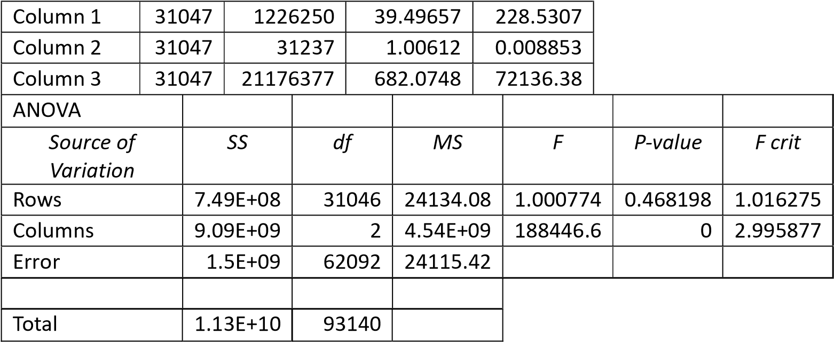

This two-factor ANOVA without replication analyses the effects of two categorical factors, rows and columns, on a continuous response variable. The rows show no significant difference in means, as indicated by their non-significant F-value and p-value. However, the columns demonstrate a highly significant difference, with an extremely high F-value and a near-zero p-value, suggesting substantial variability between column means. The error term represents variability within cells and is relatively moderate. In conclusion, while the row factor does not significantly affect the response variable, the column factor has a considerable impact, indicating that the variable represented by the columns plays a crucial role in explaining the variability in the response variable.

Descriptive Statistics:

|  |  |  |  |  |  |
| --- | --- | --- | --- | --- | --- |
| Column1 |  | Column2 |  | Column3 |  |
|  |  |  |  |  |  |
| Mean | 39.49657 | Mean | 1.00612 | Mean | 682.0748 |
| Standard Error | 0.085795 | Standard Error | 0.000534 | Standard Error | 1.524289 |
| Median | 37 | Median | 1 | Median | 646 |
| Mode | 28 | Mode | 1 | Mode | 399 |
| Standard Deviation | 15.11723 | Standard Deviation | 0.094088 | Standard Deviation | 268.5822 |
| Sample Variance | 228.5307 | Sample Variance | 0.008853 | Sample Variance | 72136.38 |
| Kurtosis | -0.1587 | Kurtosis | 475.3566 | Kurtosis | 1.768676 |
| Skewness | 0.72916 | Skewness | 19.4509 | Skewness | 1.052904 |
| Range | 60 | Range | 4 | Range | 2807 |
| Minimum | 18 | Minimum | 1 | Minimum | 229 |
| Maximum | 78 | Maximum | 5 | Maximum | 3036 |
| Sum | 1226250 | Sum | 31237 | Sum | 21176377 |
| Count | 31047 | Count | 31047 | Count | 31047 |

This table presents descriptive statistics for three variables: Column 1, Column 2, and Column 3. Each variable's statistics are listed across rows, including measures like mean, standard error, median, mode, standard deviation, sample variance, kurtosis, skewness, range, minimum, maximum, sum, and count. For Column 1, the mean is approximately 39.50, with a standard deviation of 15.12, indicating variability around the mean. Column 2 has a mean close to 1, with much lower variability compared to Column 1, as indicated by its smaller standard deviation of 0.094. Column 3 has a much higher mean of approximately 682, with a large standard deviation of 268.58, suggesting significant variability in the data. Additionally, the skewness and kurtosis values provide insights into the distribution's shape and tail behavior. Overall, these statistics offer a concise summary of the distribution, central tendency, and variability of each variable, aiding in understanding their characteristics and potential relationships in the dataset.

Correlation:

|  |  |  |  |
| --- | --- | --- | --- |
|  | Column  1 | Column  2 | Column  3 |
| Column  1 | 1 |  |  |
| Column  2 | 0.004884 | 1 |  |
| Column  3 | 0.003522 | 0.172377 | 1 |

The table appears to represent a correlation matrix, where each cell shows the correlation coefficient between two variables. In this case, Column 1 has a perfect correlation with itself (1.0), as expected. Column 2 and Column 3 also have correlations with themselves of 1.0.

The off-diagonal elements represent the correlation between different variables. For example, the correlation between Column 1 and Column 2 is approximately 0.0049, indicating a very weak positive correlation. Similarly, the correlation between Column 1 and Column 3 is approximately 0.0035, also very weak. However, the correlation between Column 2 and Column 3 is stronger, approximately 0.1724, suggesting a moderate positive correlation between these two variables.

Overall, this matrix provides insight into the relationships between the variables, with most correlations being very weak except for the moderate correlation between Column 2 and Column 3.

### Forecast Sheet: CISCO STOCKS

|  |  |  |  |  |  |  |  |
| --- | --- | --- | --- | --- | --- | --- | --- |
| Date | Open | High | Low | Close | Volume | Symbol | YTD Gains |
|  |  |  |  |  |  |  |  |
| 1/1/2003 | 13.11 | 13.69 | 13.09 | 13.64 | 61335700 | GOOGLE | 0.041221 |
| 1/2/2003 | 13.11 | 13.69 | 13.09 | 13.64 | 61335700 | GOOGLE | 0.041221 |
| 1/3/2003 | 13.58 | 13.96 | 13.56 | 13.91 | 50891700 | GOOGLE | 0.061832 |
| 1/4/2003 | 14.01 | 14.42 | 13.98 | 14.2 | 58936700 | GOOGLE | 0.083969 |
| 1/5/2003 | 14.3 | 14.7 | 14.24 | 14.6 | 83998600 | GOOGLE | 0.114504 |
| 1/6/2003 | 14.48 | 14.75 | 14.37 | 14.44 | 75927000 | GOOGLE | 0.10229 |
| 1/7/2003 | 14.7 | 15.11 | 14.65 | 14.95 | 75284400 | GOOGLE | 0.141221 |
| 1/8/2003 | 14.84 | 15.46 | 14.83 | 15.22 | 91193900 | GOOGLE | 0.161832 |
| 1/9/2003 | 15.47 | 15.52 | 15.04 | 15.28 | 66314800 | GOOGLE | 0.166412 |
| 1/10/2003 | 15.3 | 15.63 | 15.29 | 15.58 | 69977900 | GOOGLE | 0.189313 |
| 1/11/2003 | 15.57 | 15.63 | 15.13 | 15.18 | 61992300 | GOOGLE | 0.158779 |
| 1/12/2003 | 15.08 | 15.3 | 14.79 | 14.9 | 65668200 | GOOGLE | 0.137405 |
| 1/13/2003 | 14.69 | 14.72 | 14.05 | 14.13 | 81310000 | GOOGLE | 0.078626 |
| 1/14/2003 | 14.22 | 14.5 | 14.15 | 14.18 | 62930800 | GOOGLE | 0.082443 |
| 1/15/2003 | 14.19 | 14.38 | 13.9 | 13.96 | 64965500 | GOOGLE | 0.065649 |
| 1/16/2003 | 14.28 | 14.75 | 14.12 | 14.59 | 62491200 | GOOGLE | 0.11374 |
| 1/17/2003 | 14.55 | 14.56 | 13.8 | 13.86 | 70564100 | GOOGLE | 0.058015 |
| 1/18/2003 | 13.61 | 14.07 | 13.56 | 13.71 | 58554700 | GOOGLE | 0.046565 |
| 1/19/2003 | 13.88 | 14.33 | 13.8 | 14.22 | 64116500 | GOOGLE | 0.085496 |
| 1/20/2003 | 14.17 | 14.17 | 13.79 | 14.08 | 71861700 | GOOGLE | 0.074809 |
| 1/21/2003 | 14.25 | 14.36 | 13.83 | 13.87 | 68226500 | GOOGLE | 0.058779 |
| 1/22/2003 | 13.56 | 13.74 | 13.16 | 13.37 | 1.03E+08 | GOOGLE | 0.020611 |
| 1/23/2003 | 13.52 | 13.8 | 13.38 | 13.48 | 65976600 | GOOGLE | 0.029008 |
| 1/24/2003 | 13.24 | 13.24 | 12.87 | 13.2 | 1.11E+08 | GOOGLE | 0.007634 |
| 1/25/2003 | 13.31 | 13.6 | 13.1 | 13.2 | 1.15E+08 | GOOGLE | 0.007634 |
| 1/26/2003 | 13.11 | 13.41 | 13.07 | 13.24 | 58738900 | GOOGLE | 0.010687 |
| 1/27/2003 | 13.34 | 13.44 | 12.66 | 12.85 | 69851700 | GOOGLE | -0.01908 |
| 1/28/2003 | 12.92 | 13.24 | 12.78 | 13.15 | 55955700 | GOOGLE | 0.003817 |
| 1/29/2003 | 13.32 | 13.6 | 13.26 | 13.47 | 71241800 | GOOGLE | 0.028244 |
| 1/30/2003 | 13.44 | 13.65 | 13.19 | 13.2 | 58732000 | GOOGLE | 0.007634 |
| 1/31/2003 | 13.21 | 13.4 | 13.1 | 13.31 | 51646500 | GOOGLE | 0.016031 |

This forecast sheet provides a visual representation of Google's stock performance, specifically the year-to-date (YTD) gains over a period of time. Here's a detailed explanation of the various elements:

1. Chart Area: The main section of the chart displays four lines:

Blue Line: YTD Gains - This line represents the actual year-to-date gains or losses in Google's stock price over the given time period.

Orange Line: Forecast(YTD Gains) - This line represents the forecasted or predicted values for the YTD gains based on a statistical model or analysis.

Black Dotted Line: Lower Confidence Bound(YTD Gains) - This line represents the lower limit of the confidence interval for the YTD gains, indicating the range within which the actual YTD gains are expected to fall with a certain level of confidence.

Black Dashed Line: Upper Confidence Bound(YTD Gains) - This line represents the upper limit of the confidence interval for the YTD gains.

2. Time Scale: The horizontal axis represents the time scale, with data points ranging from 01-01-2009 to 08-09-2009. This time period covers approximately 8 months, allowing the visualization of Google's stock performance and forecasted gains over this duration.

3. Important Observations:

The blue line (YTD Gains) shows fluctuations, indicating periods of gains and losses in Google's stock price throughout the time period.

The orange line (Forecast(YTD Gains)) is generally flat, suggesting that the forecasted gains remain relatively constant over the given time frame.

The lower and upper confidence bounds (black dotted and dashed lines) diverge from the actual YTD gains line, indicating a wider range of possible values for the YTD gains, which could be attributed to higher uncertainty or volatility in the stock's performance.

Towards the end of the time period, the actual YTD gains (blue line) appear to deviate significantly from the forecasted values (orange line), suggesting that the forecasting model may not have accurately captured the stock's behavior during that particular period.

This forecast sheet provides a visual representation of Google's stock performance, forecasted gains, and the associated confidence intervals. It allows for the analysis of the stock's behavior over time and the evaluation of the forecasting model's accuracy. However, it's important to note that this chart alone may not provide a complete picture, and additional factors, such as market conditions, company performance, and economic indicators, should be considered for a more comprehensive analysis.